I. Abstract

Our Senior Design project explores Short-Range Wireless Routing Algorithms and a networking simulation tool, the OPNET Modeler. In this paper, the basic functionality of the OPNET Modeler and its Project Editors are discussed. A sample OPNET simulation of Carrier Sense Multiple Access (CSMA) is illustrated. Wireless Routing Algorithms are becoming very important for the modern dynamic wireless networks. A dynamic network is defined as a group of mobile hosts that communicate with each other over wireless links without any static interaction. Two routing algorithms are Temporally Ordered Routing Algorithm (TORA) and the Cluster-Based Approach. TORA is comprised of a series of “link-reversal” algorithms that explores all possible paths from the source host to the destination, finding the shortest path. TORA is explored in depth and some sample designs are included. The Cluster-Based approach differs greatly from TORA. This algorithm replaces individual hosts with a cluster of one or more hosts. The Cluster-Based approach consists of two main behavioral procedures, which manipulate a series of data structures holding the information of cluster membership and neighbor lists. This approach is discussed, designed, and implemented using C Language. Both the C code and the simulation results are included in the Appendix of this report.

II. Objective

The main objective of this senior project investigation was to explore OPNET Modeler, a routing simulation software program. This exploration included forming a better understanding of OPNET code and functionality. A wide variety of tutorials were completed, allowing for a diverse range in technology, configurations, and performance metrics. Using this OPNET Modeler information as well as background on wireless routing, existing routing algorithm protocols were researched and studied. We have researched the Temporally Ordered Routing Algorithm as well the Cluster-Based Dynamic routing algorithm. In order to incorporate the existing wireless routing algorithms we have studied into this software environment, models were created within OPNET for each algorithm. In more depth, the Dynamic Cluster algorithm was simulated in the C programming language. Under simulated changing technologies, appropriate clusters for packet transfer were created and modified.

Through our research with wireless routing algorithms and the OPNET Modeler, our scope and proposal definitions were redefined. These redefinitions will be discussed in detail.

III. Background, Research, and Results

PART 1. OPNET Modeler background

The OPNET Modeler is comprehensive software designed and manufactured by OPNET (Optimum Performance Network) Technologies. This software is the industry's leading network technology development environment, allowing the user to design and study communication networks, devices, protocols, and applications. Modeler is used by the world's most prestigious technology organizations to accelerate the Research and Development process. Modeler's object-oriented modeling approach and graphical editors mirror the structure of actual networks and network components. Modeler supports all network types and technologies. Among the many benefits of this development environment are: its hierarchical network models, its clear modeling paradigm, its finite state machine design capabilities, its integrated analysis tools, its comprehensive libraries of protocol, application, and network devices, its wireless, point-to-point, and multilinks functionality.

The main decision making process involved in design with the OPNET Modeler is the use and definition of each of the hierarchical models. Figure 1.1 gives an overview of the models and their associated editors.

Figure 1.1 Overview of the OPNET Modeler Models and Editors

OPNET Editor | Editor's Function
Project Editor | Main stage for creating network
Node Editor | Defines behavior of each network object  Behavior is defined by modules
Process Model Editor | Creates process models, controls the functionality of node  Represented by Finite State Machine
Link Model Editor | Creates new types of link objects
Path Editor | Creates new path objects (defines traffic route)
Packet Format Editor | Defines internal structure of a packet as a set of fields (can contain more than one field)
Antenna Pattern Editor  (Radio only) | Use to model the direction dependent gain properties of antennas (determine gain values)
Interface Control Editor | Defines the internal structure of IC Information (used to formalize interrupt based inter-process information
Modulation Curve Editor  (Radio only) | Used to create modulation functions to characterize the vulnerability of an information coding and modulation scheme to noise
Probability Density Function (PDF) Editor | Used to describe the spread of probability over a range of possible outcomes (associated with packet inter-arrival time)
Probe Editor | Specifies the statistics to be collected during simulation (Can set additional characteristics of each probe)
Simulation Tool | Set attributes to control that simulation's run-time characteristics
Analysis Tool | Creates scalar graphs and parametric studies, define templates to which you apply statistical data and save analysis configurations
Filter Editor | Build new filters

OPNET models are structured hierarchically, in a manner that represents real network systems. The specialized editors allow modifications and configurations at each specified hierarchical level. The OPNET Modeler environment is categorized by modeling domains. The main modeling domains are the Network, Node, and Process Domains.

Figure 1.2 OPNET Modeling Domains

Domain | Editor | Modeling Focus
Network | Project | Network topology described in terms of subnetworks, nodes, links, and geographical context.
Node | Node | Node internal architecture described in terms of functional elements and data flow between them.
Process | Process | Behavior of processes, such as protocols, algorithms, applications), specified using finite state machines and extended high-level language

PART 2. OPNET Modeler Models and Attributes

Section 2A. Network Model

The Network Model defines the overall scope of a system to be simulated. The network model specifies the objects in the system, their interconnections, and the system’s configurations. The network may be simple and contain one node, or more complex with many interconnected nodes and subnetworks. Network models are composed of the following building blocks:
- Subnetworks – encapsulates other network objects
- Communication nodes – model network objects with definable internal structure
- Communication links – provide a mechanism to transport information from in between communication nodes
Subnetworks encapsulate other network objects. They encompass a set of nodes, fixed or mobile, and links that represent a grouping of objects, such as a local area network. Subnetworks may be organized hierarchically, creating parent/child relationships and/or reiterative complexity. They may also exist independent of each other with no present interconnections. There are three types of interconnections: fixed, mobile, and satellite. Fixed subnetworks are statically placed, and their x_position and y_position can not change during simulation. Mobile subnetworks have the capability to change positions during simulation. These changes are attributed to statically defined trajectory segments, by a vector trajectory, or by direct changes to subnetworks position attributes. A satellite has the ability to change during simulation via an assigned orbit. This orbit defines its orbital path through time.

Communication nodes exist within a subnetwork and represent a network device. The node model defines the actual function and behavior of the node. Much like the subnetwork categorization, there are three types of communication nodes: fixed, mobile, and satellite. Fixed nodes are unable to change its position during simulation. A fixed node is typically used to model static network devices such as workstations, gateways, or ground stations. LAN nodes are special kinds of fixed nodes. They are used to represent an entire Ethernet, FDDI, or Token Ring LAN. LAN nodes have the ability to connect to all other objects with the same or different data rate and protocol. Mobile nodes have the ability to change positions during a simulation. A mobile node is typically used to model terrestrial network elements, such as automobiles, military vessels, etc. A satellite communication node has the ability to change position during simulation via an assigned orbit. Every satellite node is located within a subnetwork object.

Communication links allow communication between nodes in the form of packets. A link is composed of several communication channels, each defining a connection between a transmitter and receiver channel. The OPNET Modeler supports three types of links: point-to-point, bus, and radio. Point-to-point links connect a single source node to a single destination node. The number of communication channels is static, since there exists one channel between transmitter and receiver. Point-to-point links have the ability to be simplex or duplex connections. A simplex connection is defined as one from the transmitter in the source node to the receiver in the destination node. While in a duplex connection, there exists a pair of connections between nodes. Packets can flow in both directions. A bus link is a constrained broadcast communication medium. Bus links connect a fixed set of nodes to each other. Nodes that require access to and from a bus must contain bus transmitters and receivers and are attached to the bus via a tap. A tap is a simple element that is used to connect fixed node to a bus. A radio link may exist between any transmitter-receiver channel pair and is dynamically established during simulation. Radio links potentially allow all nodes to communicate with each other, based on dynamic evaluation. Since radio is a broadcast technology, the transceiver pipeline must evaluate the possible connectivity between a transmitter and receiver channel for each transmission.

Section 2B. Node Model

The Node Model defines the internal structure of the communication nodes and communication links defined by the Network Model. A node model is composed of a series of connected blocks called modules. The modules represent all the various functional areas of a node. The types of modules that can be implemented in the node model are processors, queues, generators, receivers, transmitters, and antennas.

The processor modules are used to perform the overall processing of the data packets transmitted through the node. They serve as the primary building blocks of the node models. Processors can be connected to other modules to send and receive packets via any number of packet streams. A typical processor receives the packet on the input stream, performs some processing, and sends the packet out on an output stream. Processor modules can also act as “controllers,” communicating through statistic wires or remote interrupts

The queue modules provide an extended functionality of the processor module. The queue contains an additional set of internal resources, the subqueues. Subqueues facilitate buffering and managing a collection of data packets. The capacity of each subqueue to hold data is unlimited by default, and may be defined within a subqueue. The internal structure of the queue is set up as an array of subqueues. The access to each subqueue is determined by either a physical or abstract index number.

The transmitter modules are the interface between packet streams inside a node and the communication links outside the node. They collect all packets within the node and relay them over a communication channel to the awaiting communication link. A packet received on an input stream is transmitted over the channel with same index number. Transmitter modules have an input packet stream, but no output stream, and are therefore considered to be a data sink. From the network model, the transmitter acts as the node’s output port to which the communication links are connected.

Receiver modules serve as the inbound interface between the external communication links and internal packet streams. These modules distribute packets to one or more output packet streams upon reception. A receiver is considered to be a data source. Opposite of the transmitter modules, receiver modules have no input packet stream. There are three types of receivers, as well as transmitters: point-to-point, bus, and antenna.

Antenna modules, used only in OPNET Modeler/Radio, are used to specify antenna properties for radio transmitter or receiver modules. An antenna module may accept the input streams of one or more receiver modules, and/or the output streams of one or more transmitter modules. These modules vary greatly in their size, dimensions, and overall coordinates.

Connections within the node model consist of packet streams, statistic wires, and logical associations. Packet Streams support the flow of data packets between modules. Statistic wires support the transmission of numerical state information between modules. While logical associations indicate a binding between two modules, allowing the to perform a certain function together.

Section 2C. Process Model

The main objective of the Process Model is to define the behavior of the processor and queue modules defined within the Node Model. A process model typically represents a behavioral model of a process. Such behavioral models are interrupt-driven execution and dynamic processes.

Interrupt driven executions occur when an event is delivered to a process. When this event is invoked, it is first important to determine the type of interrupt that occurred. Then more detailed attributes are analyzed including input streams or statistic wires. A process follows a cycle of invocation and rest periods, alternating Blocked and Active states. Invocation may occur at random times based on the internal and external timing of generated events.

Dynamic processes, processes invoked by other processes, occur during execution. These processes form a process hierarchy and are added to list of processes needing execution time. Multiple processes share memory architecture. Each parent-child pair can establish an independent block of memory for two-way communication. To eliminate inconsistent data structures an external copy is stored in each process’s header file.

The OPNET Modeler contains a large library package of functions, consisting of several used for operations on Dynamic Processes. Functions are defined for the creation of an initial process, which places the process in the process hierarchy. Other functions include, creating a child process, creating process handles, calling for the process ID, and destroying an expired dynamic process.

State Transitions Diagrams (STD) consists of states and transitions. States represent modes that the process can enter, while transitions specify the changes in state that are possible for the process. States consist of the state information it has chosen to retain. The executives of a state are split into the enter executive and the exit executive. This functionality allows the states to execute two separate functions depending on its transition. States are classified as either forced or unforced. In an unforced state there is a Blocked state between the execution of the enter and exit executives, that waits for an interrupt. Conversely, forced states do not allow the process to wait. Transitions describe the possible movement of a process from state to state. There are four components to a transition’s specifications: a source state, destination state, condition expression, and an executive expression. Transitions may either occur from one node to another or back to itself. Condition expressions may include complex combinations, including, state variable values, boolean values, and interrupt attributes.

Much like the Process Model input and output streams handle sending and receiving packets. Input streams accept packets from two sources: packet stream objects and a remote delivery library service. Output streams support the communication of packets via the Kernel Procedures. Both input and output streams are referenced by non-negative indices.

Section 2D. Simulation Design and Data Analysis

The OPNET Modeler networking environment allows users to simulate the models they have created in dynamic scenarios in order to study system behavior and performance. The specific features of Simulation Design are specifying data collection, simulation construction, and simulation execution. Some statistics that may be considered for verification during early modeling phase are progress, flow of data, basic statistics, and key events. Others include application-specific and behavioral data. Simulation output can be collected and displayed in four distinct forms: output vectors, output scalars, animation, and proprietary reports and files.

All of the data that is collected during the Simulation Design phase may be analyzed using the OPNET Modeler Analysis Tool. The general service of this tool is to display information in the form of graphs. The graphs represent data sets or statistics. A statistical data point consists of an abscissa and ordinate, often associated with the x- and y-coordinates. These points allow a series of data points to be graphed in relation to each other. Output scalar files combined the data collected through multiple simulations. The Analysis Tool allows the plot of several simulations to be graphed together. Overall, both the Simulation Design and Analysis Tool encompass a wide variety of functionality.

PART 3. OPNET Modeler Simulated Mobile Network

Section 3A. Introduction

Carrier Sense Multiple Access Protocols (CSMA) are protocols in which stations listen for a carrier (or a transmission) and act accordingly. 1-persistent CSMA, non-persistent CSMA, and p-persistent CSMA, are among the various versions of the carrier sense protocol.

For 1-persistent CSMA, when a station has data to send, it first listens to the channel to see if anyone else is transmitting at that moment. If the channel is busy, the station waits until it becomes idle. When the station detects an idle channel, it transmits a frame. If a collision occurs, the station waits a random amount of time and starts all over again. This version of CSMA transmits with a probability of 1 whenever it finds the channel idle.

For non-persistent CSMA, there is an attempt to be less greedy than 1-persistent CSMA. Before sending, a station senses the channel. If no one else is sending, the station begins doing so itself. However, if the channel is already in use, the station does not continually sense it for the purpose of seizing it immediately upon detecting the end of the previous transmission. Instead, it waits a random period of time and then repeats the algorithm. This algorithm, nevertheless, should lead to a better channel utilization and longer delays than 1-persistent CSMA.

P-persistent CSMA applies to slotted channels. When a station becomes ready to send, it senses the channel. If it is idle, it transmits with a probability p. With a probability q=1-p it defers until the next slot. If that slot is also idle, it either transmits or defers again, with the probabilities p and q. The process is repeated until either the frame has been transmitted or another station has begun transmitting. If another station has begun transmitting, it acts as if there had been a collision, meaning that it waits a random time and starts again). If the station initially senses the channel busy, it waits until the next slot and applies the above algorithm.

Section 3B. CSMA and OPNET Overview

The tutorial that this project is base on constructs two models: Aloha model and CSMA model. The aloha model will be designed first since it is the simplest of the channel access model. The task in this lesson is to design models which incorporate the aloha random access method and the 1-persistent Carrier Sense Multiple Access (CSMA) method on a multi-tap bus link where multiple nodes are connected through a shared channel. Each method’s performance will be compared against the others.

Section 3C. Design

The design strategy for the aloha and CSMA model is to employ the same network model. Both network models will use a common transmitter node model, which sends packets and a common receiver node model, which performs network monitoring. By changing the process model attribute of the node models, new simulations using either aloha or CSMA properties can be built quickly. The transmitter node process model will be unique, whereas the receiver node process model is generic and will remain unchanged.

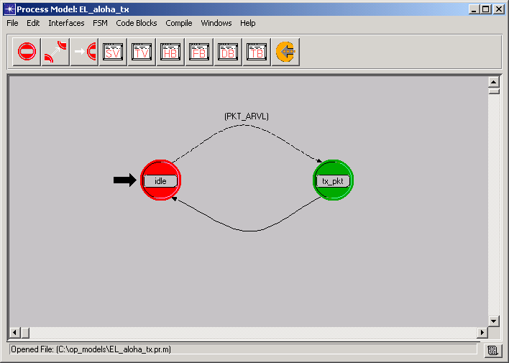

Figure 3.1. Transmitter Process Model
Red idle state is unforced. Green tx_pkt state is forced. At the unforced idle state, the packet arrival interrupt can be selectively detected by an appropriate transition.
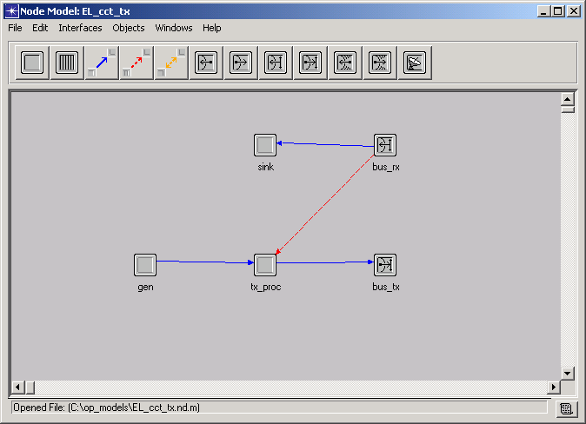

Figure 3.2. Generic Transmitter Node Model

This enhanced transmitter node model will enable the support of the eventual full duplex capability of the CSMA protocol. The sink processor is added to accept and destroy the packets received by the receiver module. When the statistic wire (the one in red) is enabled in the CSMA model, it will inform the process of the busy status of the channel and provide interrupts to the process when the channel condition changes.

The next step is to construct the generic receiver process and node model. The purpose of the receiver process is to count packets and record statistics. It can also be used to monitor network performance whether the packets are transmitted in accordance with the CSMA channel access methods.

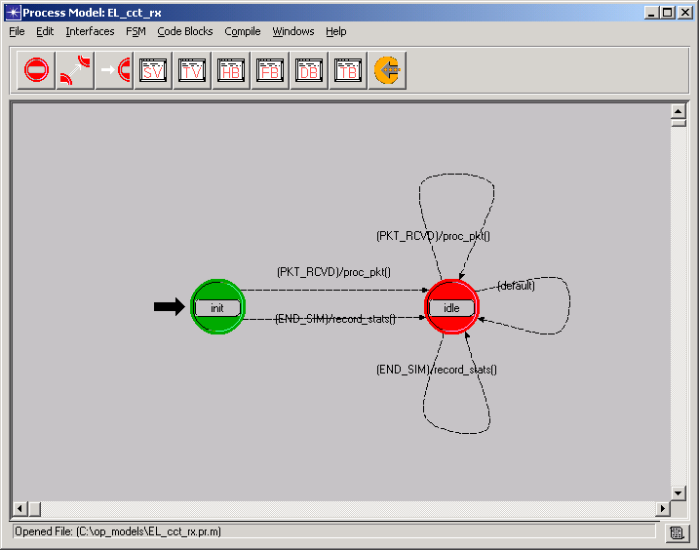

Figure 3.3. Receiver Process Model with five transition states
State variables declared in the state variable block will keep track of the number of valid received packets.

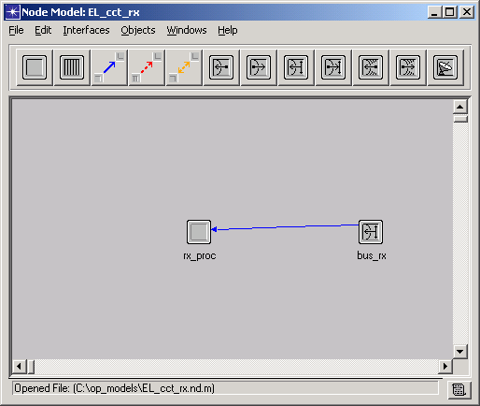

Figure 3.4. Generic Receiver Node Model

Section 3D. Analyzing Results

Aloha~

The aloha channel performance can be measured according to the number of successful received packets as a function of the packets submitted, regardless of whether the packets are original or retransmitted. For this network, channel throughput is a typical measurement of network performance.

The result of the simulation are stored as scalar values in the output scalar file which allows the user to view the network’s performance as a function of an input parameter rather than a function of time. The channel throughput as a function of channel traffic across all of the simulations can be viewed in the Analysis Configuration Editor in OPNET.

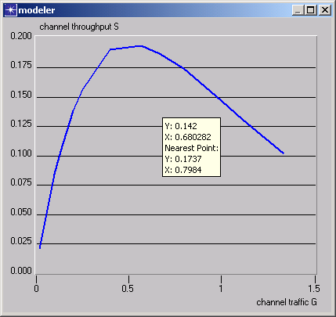

Figure 3.5. Aloha Simulation Results

Theoretical analyses have shown that a pure aloha system has a channel throughput S as a function of channel traffic G given by S=Ge^(-2G). This relationship gives a maximum channel throughput of Smax=0.18. At low traffic levels, collision seldom occur. At high traffic levels, the channel is overwhelmed and excessive collision prevent packets from being successfully received. This behavior is demonstrated by the simulation graph in figure 3.5. As the graph shows, the maximum throughput is achieved near G=0.5 and is close to the expected value of 0.18.

CSMA ~

The performance of the aloha random access protocol can be enhanced by adding a carrier sense capability. The carrier sense capability is employed in the classical CSMA protocol, which requires a source node to sense the channel and determine that it is free before committing to a transmission.

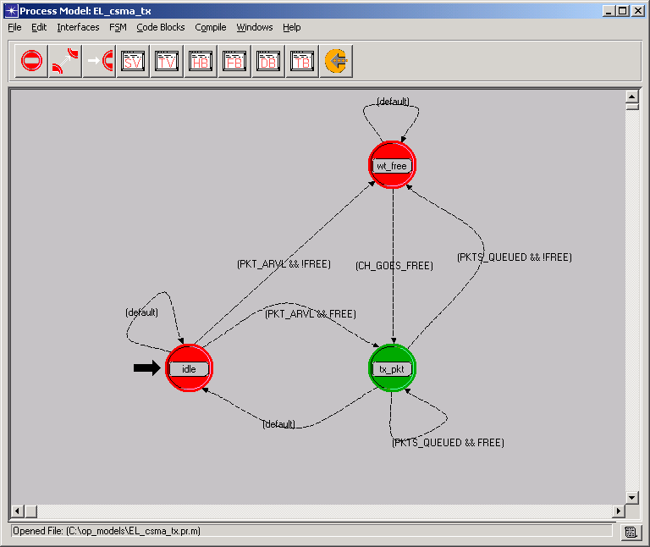

Figure 3.6. Enhanced states and transitions CSMA process model

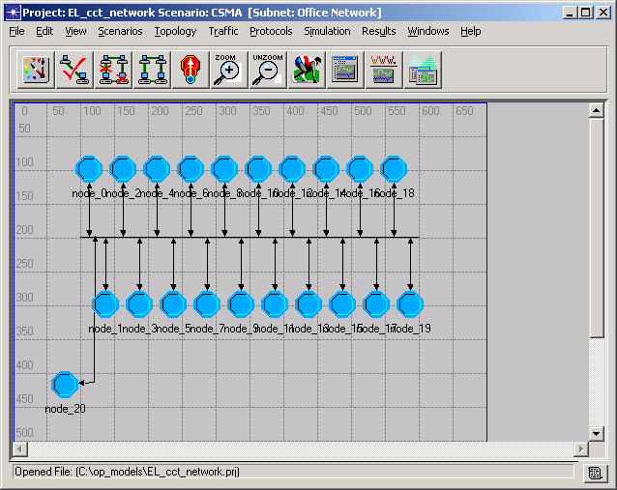

Figure 3.7. CSMA network model

The results of the CSMA simulation are also viewed using the Analysis Configuration Editor in OPNET. As figure 3.8 shows, the CSMA protocol is seen to have achieved a maximum channel throughput of about 0.5. We can also compare the performance of the aloha and CSMA protocol directly by displaying both the aloha and the CSMA curve simultaneously on the same graph as shown in figure 3.9.

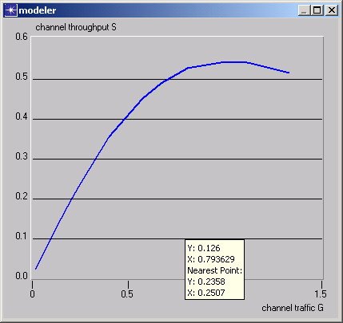

Figure 3.8. Result of the CSMA simulation

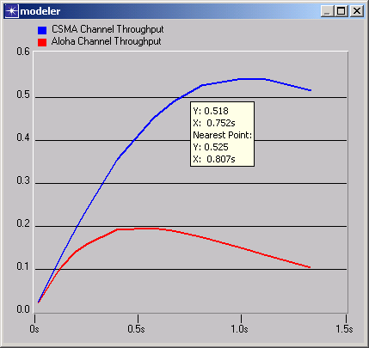

Figure 3.9. Display of the aloha curve and the CSMA curve simultaneously to make comparisons.

The CSMA protocol is seen to be superior to the aloha protocol at all channel traffic loads. The theoretical channel throughput S as a function of channel traffic G in a 1-persistent CSMA channel with negligible propagation delay is given by S=G(1+G)e^-G/(G+e^-G). This formula predicts a maximum throughput of approximately 0.5 at a channel traffic of approximately 1.0. The results as shown in the graph agrees with this prediction.

PART 4. Introduction To The Wireless LAN

The Wireless LAN (WLAN) protocol is based on the IEEE standard, 802.11. This standard defines a medium access control (MAC) sublayer and three physical layers. The architecture of the WLAN is designed to support a system where most routing and connectivity decisions are distributed across the mobile stations. The basic building blocks of the 802.11 based WLAN are:
- A station that connects to the wireless medium. The station may be mobile, portable, or stationary.
- A Basic Service Set (BSS), a set of stations that communicate to one another. Adhoc networks exist when all stations in a set can communicate directly with no connection to a wired network.
- An Extended Service Set, a set of infrastructure BSSs. Access points within the BSSs communicate among each other to forward traffic to one another.

The MAC of the WLAN supplies the functionality to provide the efficient transmission of user data over wireless media. A MAC Frame Exchange provides a reliable data delivery service to the user. This frame exchange consists of a data frame sent from the source to the destination and an acknowledgement sent from the destination to the source. If no acknowledgement is received by the source, then the data is transmitted. A second mechanism of the MAC is the Basic Access Mechanism. This attempts to provide fair control access of shared wireless media. The Basic Access Mechanism is Carrier Sense Multiple Access with Collision Avoidance (CSMA/CA). In this access, a station will listen to the medium before transmission, if it detects an existing transmission, it will defer for a random amount of time and repeat. Collision Avoidance is achieved by using a network allocation vector that determines when the medium will become available. The third function of the MAC sublayer is to provide protection for the data it delivers. A private service, Wired Equivalent Privacy, performs this by encrypting the data it transmits.

In the Network Model of the WLAN implementation, BSS can be formed as both infrastructure BSS, with access points to other BSSs, or as independent BSSs, communicating to only those in their region, see Figure 4.1.

Figure 4.1 (a) Basic Service Set with Access Points; (b) Independent Basic Service Set

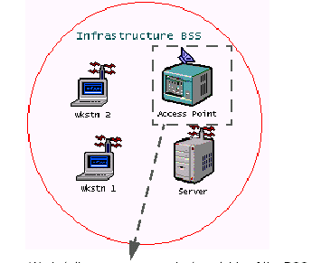
(a)

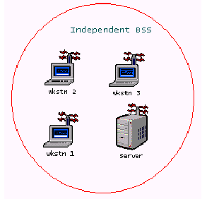
(b)

The Node Model defines the behavior of the individual nodes. The WLAN modeling of the MAC and the physical layer is comprised of the wireless_lan_mac process, transmitter, receiver, and the channel streams. In the Node Model appropriate thresholds, data rates, physical characteristics, retry limits, and other WLAN statistics are also defined.

PART 5. Introduction To Dynamic Networks

Dynamic Wireless Network consists of mobile hosts that communicate with one another over wireless links without any static network interaction. The mobile hosts have the functionality to both communicate to other hosts in its region as well as the transmission of data packets. Some common dynamic networks include both packet radio and ad-hoc wireless networks. In some networks, it is possible for each mobile user to connect to a static network such as a wide area network or satellite network. Unfortunately, these methods are usually associated with overhead and high costs. Routing algorithms have been developed to set up communication links without any static network interaction. Due to the limited range of wireless transreceivers, mobile hosts’ communication links can only be implemented in their geographic region. This creates the need for a complex network to handle and maintain the forwarding of data packets.

Previous work includes the creation of conventional shortest path algorithms much like the Dijkstra’s theorem of mathematics. Through the development of these algorithms, a set of routing algorithm standards was created. This set includes:

- Simplicity
- Loop-free
- Low convergence time
- Low storage and memory overhead
- Low computational and transmission overhead
  - Limited bandwidth due to low power devices

There are some problems using these convention protocol standards with dynamic networks. Existing protocols could place a heavy computational burden on mobile computers in terms of battery power, and the wireless networks in terms of limited bandwidth. Also the convergence characteristics, time to converge to new routes after a topology change, of these protocols is not good enough to suit a dynamic network. Conventional convergence requires frequent broadcast of routing tables. The overhead of these broadcasts increase greatly as the number of mobile hosts increases. During a topology update operation, all nodes end up sending an update message to each of their neighbors. In a dynamic network, where topology changes occur quite frequently, the broadcast overhead for such a routing algorithm is extremely high.

Along with variations of the conventional routing standards, it is most important for a dynamic routing protocol to maintain connectivity between the hosts in a fast changing topology. Maintaining routes from all requesting source nodes to the destination (rather than from all nodes, those who are both requesting a non-requesting), allows for a reduction in topology update overhead.

PART 6. Temporally Ordered Routing Algorithm

Section 6A. Introduction

Internet Protocol (IP) networking technology is primarily based on a hardwired infrastructure. Since the interconnections between the routers in a conventional IP network are hardwired, the physical topology of the network is relatively static. Thus, traditional IP routing protocols have been designed for operation in a quasi-static networking environment with hardwired links. These routing protocols are typically based on shortest path algorithms and seek to provide least cost paths with respect to a particular cost metric. This shortest path routing paradigm is a good fit for the conventional networking environment in which it is has evolved.

Section 6B. Overview

Temporally Ordered Routing Algorithm (TORA) is a network routing protocol which has been designed for use in Mobile Wireless Networks. These networks can be viewed as a collection of routers, equipped with wireless receiver/transmitters, which are free to move about arbitrarily. The status of the communication links between the routers, at any given time, is a function of their positions, transmission power levels, antenna patterns and co-channel interference levels. The mobility of the routers and the variability of other connectivity factors often result in a network with potentially rapid and unpredictable changing topologies. Congested links are also an expected characteristic of such a network. Wireless links inherently have significantly lower capacity than hardwired links and are therefore more prone to congestion.

TORA is designed to minimize reaction to topological changes. The basic, underlying, routing mechanism of TORA is neither a distance-vector nor a link-state algorithm. It is one of a family of “link-reversal” algorithms. A key concept in its design is that it decouples the generation of far-reaching control message propagation from the rate of topological changes. The messaging is typically localized to a very small set of nodes near the change without having to resort to a dynamic, hierarchical routing solution with its attendant complexity. The protocol builds a loop free, multi-path routing structure that is used as the basis for forwarding traffic to a given destination. The protocol can simultaneously support both source-initiated, on-demand routing for some destinations and destination-initiated, proactive routing for other destinations. This behavior makes it highly adaptive and well suited for a dynamic mobile network with limited bandwidth. Also, this second mechanism, which is independent of network topology dynamics, is used as a means of route optimization and soft-state route verification. The design and flexibility of TORA allow its operation to be biased towards high reactivity (i.e., low time complexity) and bandwidth conservation (i.e., low communication complexity) rather than routing optimality.

TORA is distributed in nature. The routers need only to maintain information about adjacent routers (i.e., one hop knowledge). Like a distance vector routing approach, TORA maintains state on a per-destination basis. However, TORA does not continuously execute a shortest path computation and thus the metric used to establish the routing structure does not represent a distance. The destination-oriented nature of the routing structure in TORA supports a mix of reactive and proactive routing on a per-destination basis. During reactive operation, sources initiate the establishment of routes to a given destination on demand. This mode of operation may be advantageous in dynamic networks with relatively sparse traffic patterns, since it may not be necessary nor desirable to maintain routes between every source/destination pair at all times. At the same time, selected destination can initiate proactive operation, resembling traditional table driven routing approaches. This allows routes to be proactively frequently required (e.g., servers or gateways to hardwired infrastructure).

To summarize, TORA has the following desirable properties that makes it well-suited for use in the mobile wireless networking environment:
- Executes distributedly
- Provides loop-free routes
- Provides multiple routes (to alleviate congestion)
- Establishes routes quickly (so they maybe used before the topology changes)
- Minimize algorithmic reactions/communication overhead (to conserve available bandwidth and increase adaptability)
The last property, minimizing communication overhead and maximizing routing efficiency, are achieved with the following concepts:
- Routes established only when necessary by constructing a directed acyclic graph rooted at the destination using a “query/reply” process
- Reaction to link failure only when necessary (i.e., when a node loses its last downstream link)
- Scope of failure reactions minimized (i.e., the number of nodes that must participate)
- No reaction to link activation

Section 6C. Functional Description

TORA has been designed to work on top of lower layer mechanism or protocols that provide some basic services between neighboring routers, in other words, below the Internet Protocol (IP). These services include: Link status sensing and neighboring discovery; Reliable, in-order control packet delivery; Link and network layer address resolution and mapping; Security authentication. Events such as the reception of control messages and changes in connectivity with neighboring routers trigger TORA’s algorithmic reactions. TORA does not have the properties of link state or distance-vector algorithms, but link-reversal, as stated previously. The protocol is adaptive, and highly scalable.

A logically separated version of TORA is run for each “destination” to which routing is required. The following discussion focuses on a single version of TORA running for a given destination. The term destination refers to a traditional IP routing destination, which is identified by an IP address and mask (or prefix). Thus, the route to a destination may correspond to the individual address of an interface on a specific machine (or host) or an aggregation of addresses (i.e., a network route).

TORA assigns directions to the links between routers to form a routing structure that is used to forward datagrams to the destination. A router assigns a direction (upstream or downstream) to the link with a neighboring router based on the relative values of a metric associated with each router. The metric maintained by a router can conceptually be thought of as the router’s “height” (links that are directed from the higher router to the lower router). The significance of the heights and the link directional assignments is that a router may only forward datagrams downstream. Links from a router to any neighboring routers with an unknown or undefined height are considered undirected and cannot be used for forwarding. Collectively, the heights of the routers and the link directional assignments form a loop free, multi-path routing structure in which all directed paths lead downstream to the destination.

To demonstrate this downstream effect, an acyclic graph is shown in Figure 6.1.

B
A
C
D
E
Dest

Relative Height of the Routers
H(C) > H(B) > H(E) > H(Dest)
H(D) > H(A) > H(B) > H(E) > H(Dest)

Figure 6.1. Conceptual representation of the directed acyclic graph (DAG) defined by the relative height of network routers.

Note that in this figure, router C is closer to the destination than router B in terms of the number of hops, but the height metric of router C is greater than that of router B.

The DAG (directed acyclic graph), by design, ensures that all directed paths are loop free and lead to the destination. Links between routers are directed (to form the DAG) based on a metric, maintained by the routers, that is viewed as a “height” as mentioned previously. A link is directed from the “higher” router to the “lower” router as the “height” label implies. Given the height of a router, H[i], and the height of an adjacent neighbor router, H[j], the link directions are assigned as follows:
- If H[j] = = NULL then unassigned
- Else if H[i] = = NULL then downstream
- Else if H[i]>H[j] then downstream
- Else if H[i] < H[j] then upstream

A three dimensional illustration of the DAG for a given destination is shown in Figure 6.2.

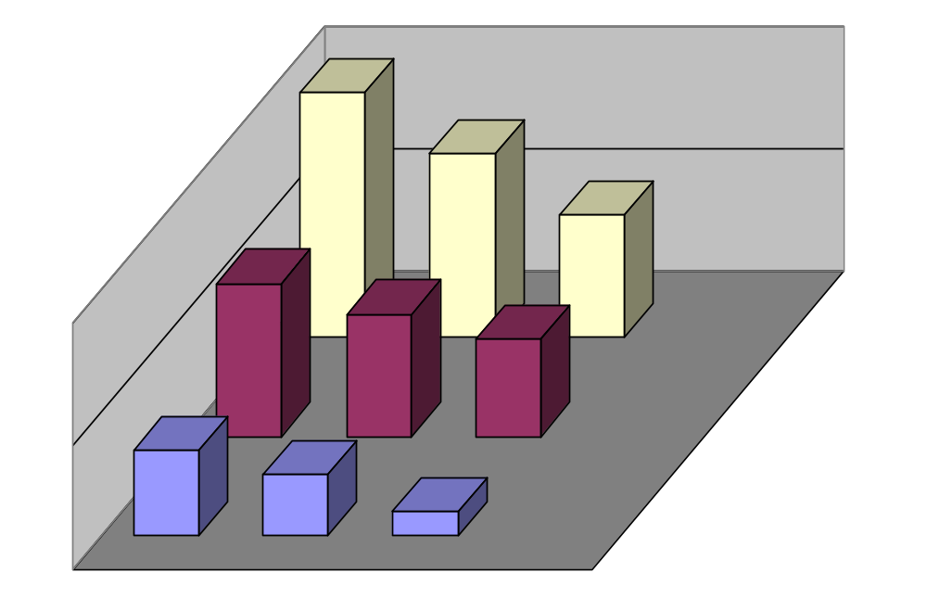
Destination
Source

Figure 6.2. A three dimensional illustration of the DAG formed by the relative heights of the routers

The “height” of each node in the TORA network keeps the following five values about its adjacent nodes:
- oid: The old unique ID of the node that defined the new reference level
- τ: A clock tag set to the time of the link failure, where nodes should have synchronized clocks with an external time source such as the Global Positioning System (GPS)
- r: A reflection indicator bit
- δ: A propagation ordering parameter, height
- i: The current unique ID of the node itself

Each value in the ordered quintuple of the height metric (τ, oid, r, δ, i) serves a specific purpose in providing the desired functionality in the failure reaction mechanism. The first three elements collectively represent the reference level. A new reference level is defined each time a node loses its last downstream link due to a link failure. The last two values define an offset with respect to the reference level, which were the first three values.

Another good example of how this routing works is to view the topology as water flowing down the hill through pipes. The top of the hill is the source, pipes are links, and pipe connections are nodes. TORA assigns level numbers to each node down the hill. Then two intermediate nodes cannot communicate, the last node raises its level higher than any of its neighbors, so that water, which is the data, flows back out of it. Figure 6.3 illustrates this effect.

RTS
CTS
DATA
ACK

Figure 6.3. TORA water flow analogy
TORA is quick to discover multiple routes on demand. Routes do not have to be optimal, but it guarantees that all routes are loop-free. TORA only does routing job, and heavily depends on Internet MANET Encapsulation Protocol (IMEP).

TORA can be separated into four basic functions: creating routes, maintaining routes, erasing routes, and optimizing routes. Creating a route from a given router to the destination requires establishment of a sequence of directed links leading from the router to the destination. This function is only initiated when a router with no directed links requires a route to the destination (i.e., on demand). Thus, creating routes essentially corresponds to assigning directions to links in an undirected network or portion of the network. Immediately following a link failure there may be directed paths that no longer lead to the destination. Maintaining routes refers to the adapting the routing structure in response to network topological changes. For example, following the loss of some router's last downstream link, some directed paths may temporarily no longer lead to the destination. This event triggers a sequence of directed link reversals (caused by the re-selection of router heights), which re-orients the routing structure such that all directed paths again lead to the destination. In cases where the network becomes partitioned, links in the portion of the network that has become partitioned from the destination must be marked as undirected to erase invalid routes. During this erasing routes process, routers set their heights to null and their adjacent links become undirected. Finally, TORA includes a secondary mechanism for optimizing routes, in which routers re-select their heights in order to improve the routing structure. TORA accomplishes these four functions through the use of four distinct control packets: query (QRY), update (UPD), clear (CLR), and optimization (OPT).

In addition, TORA receives notification of link status changes from lower layer mechanisms or protocols. It is anticipated that the TORA process will have access to all the information about the connections. Thus, upon notification, TORA will have sufficient information to determine if any new links have been established or any existing links have been severed. In addition, since a link is potentially composed of multiple connections, it is also possible for a connection that was used in the routing table to be severed without resulting in the corresponding link being severed. In this care TORA must modify the appropriate routing table entries.

Section 6D. Creating Routes in TORA

Creating routes can be initiated on-demand by a source or proactively by a destination. In either case, routers select heights with respect to the given destination and assign directions to the links between neighboring routers.

In the on-demand mode, creating routes is accomplished via a query – reply mechanism using QRY and UPD packets. A source initiates the process by sending a QRY packet to its neighbors that identifies the destination for which a route is requested. The QRY packet is propagated out from the source (i.e., processed and forwarded by neighboring routers) until one or more routers that have a trusted route to the destination receive it. As the QRY packet is forwarded, routers set a route-requested flag and discard any subsequent QRY packets received for the same destination. The route-requested flag suppresses redundant route requests and reduces the need for subsequent route requests when a destination is temporarily unreachable. Routers that have a trusted route to the destination respond to the QRY packet by sending an UPD packet to their neighbors that identifies the relevant destination and the height of the router sending the UPD packet. Routers also maintain the time at which an UPD packet was last sent to its neighbors and the time at which links to neighboring routers became active, to reduce redundant replies to a given route request. When a router with the route-requested flag set receives an UPD packet, it sets its height and sends an UPD packet to its neighbors that identify the relevant destination and the new height of the router sending the UPD packet. Thus, routers in the network select heights for the requested destination learn of their neighbors heights for the destination and assign link directions based on those heights. To ensure that a route request continues to propagate when the destination was initially unreachable, routers with the route-requested flag set must resend a QRY packet upon activation of a new link (i.e., discovery of a new neighbor).

In the proactive mode, the destination initiates the creating routes process by sending an OPT packet that is processed and forwarded by neighboring routers. The OPT packet identifies the destination, the mode of operation for the destination and the height of the router sending the OPT packet. The OPT packet also contains a sequence number used to uniquely identify the packet and ensure that each router processes and forwards a given OPT packet from a destination at most once. As the OPT packet is forwarded, routers set their mode of operation correspondingly, reselect their heights, and send an OPT packet to their neighbors that identifies the relevant destination and the new height of the router sending the UPD packet.

A decision tree can be used to illustrate the process of creating a route in TORA, and is depicted in Figure 6.4.

Node i received QRY from neighbor k for destination j
RT_REQ[j]?
Return
Height[j].r= =0?
TIME_ACT[j][k] > TIME_UPD[j]
Height [j][n].r = = 0 for any n
Return
Return
Return
Return
TIME_UPD[j] <- Current Time Send UPD Packet to all neighbors
RT_REQ[j] <- true Send QRY to all neighbors if NUM_ACTIVE[j]>1
For all n with Height[j][n].r = = 0, find the entry m with the minimum height, Height[j]<-Height[j][m] Increment Height[j].delta Height[j].Id<-I Update LNK_STAT[j][n] for all n. TIME_UPD <- Current Time Send UPD packet to all neighbors

Figure 6.4. QRY Processing in TORA

OPNET was also used to create a process model of how the QRY packet is streamed through the network. A snapshot of the process model is shown in Figure 6.5, the decisions of the transition states were base on the decision tree in Figure 6.4. The process model is constructed with finite state machines.

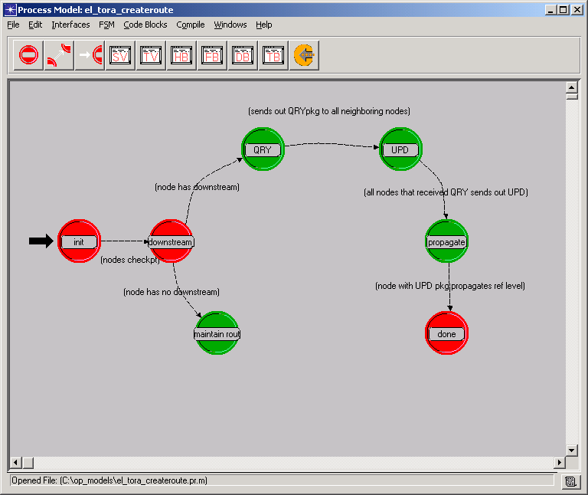

Figure 6.5. Snapshot of QRY Process Model in OPNET

The next set of graphics show a step-by-step process of creating a route. The sample network consists of eight nodes, labeled A-H, and will be the network used in the rest of this document for other process illustrations.

Route Creation Example
(A Circle around a node indicates that the route-required flag is true or set)

(-,-,-,-,G)
(-,-,-,-,C)
(-,-,-,-,A)
(-,-,-,-,D)
(-,-,-,-,B)
(-,-,-,-,E)
(0,0,0,0,F)
(-,-,-,-,H)
DEST
QRY

Picture 6.D.1. Node C requires a route to node F. Hence, it broadcasts a QRY packet.

(-,-,-,-,G)
(-,-,-,-,C)
(-,-,-,-,A)
(-,-,-,-,D)
(-,-,-,-,B)
(-,-,-,-,E)
(0,0,0,0,F)
(-,-,-,-,H)
DEST
QRY
QRY

Picture 6.D.2. Node A and Node G propagates the QRY packet.

(-,-,-,-,G)
(-,-,-,-,C)
(-,-,-,-,A)
(-,-,-,-,D)
(-,-,-,-,B)
(-,-,-,-,E)
(0,0,0,0,F)
(0,0,0,1,H)
DEST
QRY
QRY
UPD

Picture 6.D.3. Node B and Node D propagates the QRY packet. Node H generates a UPD packet
(0,0,0,2,G)
(-,-,-,-,C)
(-,-,-,-,A)
(0,0,0,2,D)
(-,-,-,-,B)
(0,0,0,1,E)
(0,0,0,0,F)
(0,0,0,1,H)
DEST
UPD
UPD
UPD

Picture 6.D.4. Node D and Node G propagate the UPD packet. Node E generates a UPD packet

(0,0,0,2,G)
(0,0,0,3,C)
(0,0,0,3,A)
(0,0,0,2,D)
(0,0,0,2,B)
(0,0,0,1,E)
(0,0,0,0,F)
(0,0,0,1,H)
DEST
UPD
UPD
UPD

Picture 6.D.5. Node A, Node B, and Node C propagates the UPD packet.
(0,0,0,2,G)
(0,0,0,3,C)
(0,0,0,3,A)
(0,0,0,2,D)
(0,0,0,2,B)
(0,0,0,1,E)
(0,0,0,0,F)
(0,0,0,1,H)
DEST

Picture 6.D.6. Route creation is completed.

Section 6E. Maintaining Routes in TORA

Maintaining routes is only performed for nodes that have a height other than NULL. Furthermore, any neighbor's height that is NULL is not used for the computations. A node i is said to have no downstream links if HEIGHT < HT_NEIGH[k] for all non-NULL neighbors k. This will result in one of five possible reactions depending on the state of the node and the preceding event. Each node (other than the destination) that has no downstream links modifies its height, HEIGHT= (τ[i], oid[i], r[i], δ[i], i), as follows:

Case 1 (Generate):
- Node i has no downstream links (due to a link failure).
- (τ [i], oid[i], r[i]) = (t, i, 0), where t is the time of the failure.
- (δ [i],i) = (0, i)

Essentially, node i defines a new reference level. The above assumes node i has at least one upstream neighbor. If node I has no upstream neighbors it simply sets its height to NULL.

Case 2 (Propagate):
- Node i has no downstream links (due to a link reversal following reception of an UPD packet)
- Ordered sets (τ [k], oid[k], r[k]) are not equal for all neighbors k.
- (τ [i], oid[i], r[i]) = max{(t[k], oid[k], r[k]) of all neighbors k}
- (δ [i],i) = ( δ [m]-1, i), where m is the lowest neighbor with the maximum reference level defined above.

In essence, node i propagates the reference level of its highest neighbor and selects a height that is lower than all neighbors with that reference level.

Case 3 (Reflect):
- Node i has no downstream links (due to a link reversal following reception of an UPD packet) and the ordered sets
- (τ [k], oid[k], r[k]) are equal with r[k] = 0 for all neighbors k.
- (τ [i], oid[i], r[i]) = ( τ [k], oid[k], 1)
- (δ [i],i) = (0, i)

In essence, the same level (which has not been "reflected") has propagated to node i from all of its neighbors. Node i "reflects" back a higher sub-level by setting the bit r.

Case 4 (Detect):
- Node i has no downstream links (due to a link reversal following reception of an UPD packet)
- Ordered sets (τ [k], oid[k], r[k]) are equal with r[k] = 1 for all neighbors k, and oid[k] = i (i.e., node i defined the level).
- (τ [i], oid[i], r[i]) = (-, -, -)
- (δ [i],i) = (-, i)

In essence, the last reference level defined by node i has been reflected and propagated back as a higher sub-level from all of its neighbors. This corresponds to detection of a partition. Node i must initiate the process of erasing invalid routes as discussed in the next section.

Case 5 (Generate):
- Node i has no downstream links (due to a link reversal following reception of an UPD packet)
- Ordered sets (τ [k], oid[k], r[k]) are equal with r[k] = 1 for all neighbors k, and oid[k] != i (i.e., node i did not define the level).
- (τ [i], oid[i], r[i]) = (t, i, 0), where t is the time of the failure
- (δ [i],i) = (0, i)

In essence, node i experienced a link failure (which did not require reaction) between the time it propagated a reference level and the reflected higher sub-level returned from all neighbors. This is not necessarily an indication of a partition. Node i defines a new reference level.

Following the determination of its new height in cases 1, 2, 3, and 5, node i updates all the entries in its link-status table; and broadcasts an UPD packet to all neighbors k. The UPD packet consists of the destination-ID, j, and the new height of the node i that is broadcasting the packet, HEIGHT. When a node i receives an UPD packet from a neighbor k, node i reacts as described in the creating routes section and in accordance with the cases outlined above. In the event of the failure a link (i, k) that is not its last downstream link, node i simply removes the entries HT_NEIGH[k] and LNK_STAT[k] in its height and link-status tables.

A decision tree can be used to illustrate the process of maintaining a route in TORA, following the cases as mentioned above, and is depicted in Figure 6.6.

Node i loses its last downstream link
Was the link lost due to a failure?
Case 1:
Generate a new reference level
Do all of the neighbors have the same reference level?
Is the reference bit r in that reference level set to 1?
Case 2:
Propagate the highest neighbor’s reference level
Case 3:
Reflect back a higher sub-level
Did this node originally define that reference level (oid=1)?
Case 4:
Partition Detected, erase invalid routes
Case 5:
Generate new reference level
Yes
Yes
Yes
Yes
No
No
No
No

Figure 6.6. TORA Route Maintenance Decision Tree

OPNET was also used to create a process model of how the route is maintained. A snapshot of the process model is shown in Figure 6.7, the decisions of the transition states were base on the decision tree in Figure 6.6.

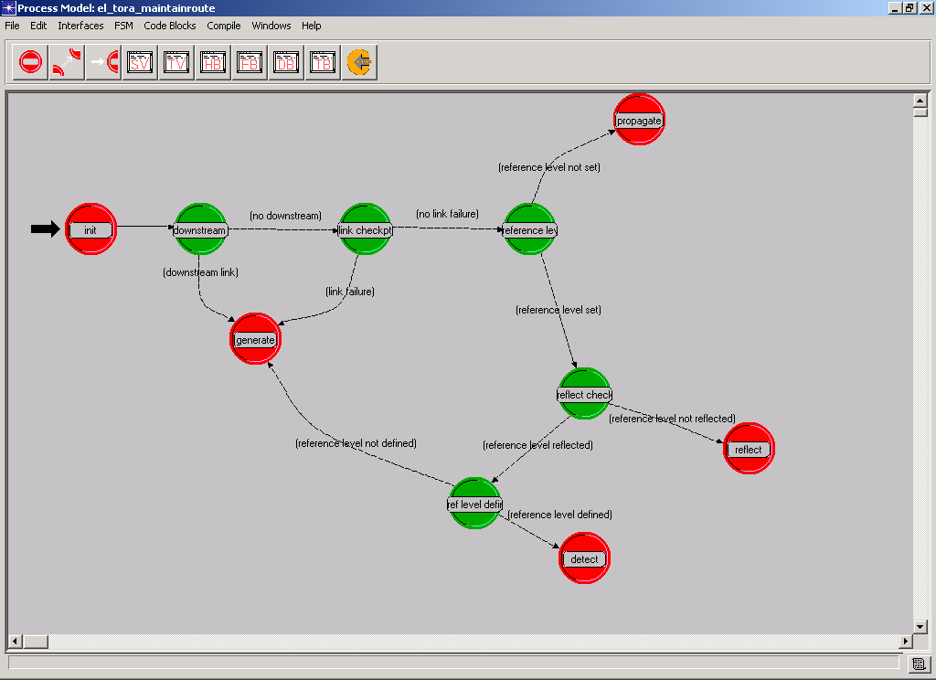

Figure 6.7. Process Model of Maintaining Route in TORA

The next set of graphics show a step by step process of maintaining a route with different scenarios. The sample network consists of eight nodes, labeled A-H, as was used in the previous create route example.

Route Maintenance Example
(Scenario 1: Link Failure that does not require a reaction)

(0,0,0,2,G)
(0,0,0,3,C)
(0,0,0,3,A)
(0,0,0,2,D)
(0,0,0,2,B)
(0,0,0,1,E)
(0,0,0,0,F)
(0,0,0,1,H)
DEST

Picture 6.E1.1. The link between Node B and Node E fails

(0,0,0,2,G)
(0,0,0,3,C)
(0,0,0,3,A)
(0,0,0,2,D)
(0,0,0,2,B)
(0,0,0,1,E)
(0,0,0,0,F)
(0,0,0,1,H)
DEST

Picture 6.E1.2. Each node has atleast one downstream link, no route maintenance is necessary.

Route Maintenance Example
(Scenario 2: Link failure that requires a reaction)
(0,0,0,2,G)
(0,0,0,3,C)
(0,0,0,3,A)
(0,0,0,2,D)
(0,0,0,2,B)
(0,0,0,1,E)
(0,0,0,0,F)
(0,0,0,1,H)
DEST

Picture 6.E2.1. The link between Node D and Node H fails.

(0,0,0,2,G)
(0,0,0,3,C)
(0,0,0,3,A)
(1,D,0,0,D)
(0,0,0,2,B)
(0,0,0,1,E)
(0,0,0,0,F)
(0,0,0,1,H)
DEST
UPD
Picture 6.E2.2. Node D has no downstream links, therefore it defines a new reference level. Node B in turn, has no downstream links.
(0,0,0,2,G)
(0,0,0,3,C)
(0,0,0,3,A)
(1,D,0,0,D)
(1,D,0,-1,B)
(0,0,0,1,E)
(0,0,0,0,F)
(0,0,0,1,H)
DEST
UPD

Picture 6.E2.3. Node B propagates the reference level defined by Node D. Node A becomes a node without downstream links.

(0,0,0,2,G)
(0,0,0,3,C)
(1,D,0,-2,A)
(1,D,0,0,D)
(1,D,0,-1,B)
(0,0,0,1,E)
(0,0,0,0,F)
(0,0,0,1,H)
DEST
UPD

Picture 6.E2.4. Node A propagates the reference level defined by Node D. All nodes have downstream link. Route maintenance is complete.

Route Maintenance Example
(Scenario 3: Link Failure that partitions the network)

(0,0,0,2,G)
(0,0,0,3,C)
(1,D,0,-2,A)
(1,D,0,0,D)
(1,D,0,-1,B)
(0,0,0,1,E)
(0,0,0,0,F)
(0,0,0,1,H)
DEST

Picture 6.E3.1. Link between Node C and Node G fails, causing a partition. Node C has no downstream links after link failure.

(0,0,0,2,G)
(2,C,0,0,C)
(1,D,0,-2,A)
(1,D,0,0,D)
(1,D,0,-1,B)
(0,0,0,1,E)
(0,0,0,0,F)
(0,0,0,1,H)
DEST
UPD
Picture 6.E3.2. Node C defines new reference level and sends UPD packet. Node A has no downstream link.

(0,0,0,2,G)
(2,C,0,0,C)
(2,C,0,-1,A)
(1,D,0,0,D)
(1,D,0,-1,B)
(0,0,0,1,E)
(0,0,0,0,F)
(0,0,0,1,H)
DEST
UPD

Picture 6.E3.3. Node A propagates reference level, which causes Node B to have no downstream links.

(0,0,0,2,G)
(2,C,0,0,C)
(2,C,0,-1,A)
(1,D,0,0,D)
(2,C,0,-2,B)
(0,0,0,1,E)
(0,0,0,0,F)
(0,0,0,1,H)
DEST
UPD

Picture 6.E3.4. Node B propagates reference level which causes Node D to have no downstream links.

(0,0,0,2,G)
(2,C,0,0,C)
(2,C,0,-1,A)
(2,C,1,0,D)
(2,C,0,-2,B)
(0,0,0,1,E)
(0,0,0,0,F)
(0,0,0,1,H)
DEST
UPD

Picture 6.E3.5. Node D then reflects the reference level causing Node B to have no downstream links again.

(0,0,0,2,G)
(2,C,0,0,C)
(2,C,0,-1,A)
(2,C,1,0,D)
(2,C,1,-1,B)
(0,0,0,1,E)
(0,0,0,0,F)
(0,0,0,1,H)
DEST
UPD
Picture 6.E3.6. Node B propagates reference level causing Node A to have no downstream links.
(0,0,0,2,G)
(2,C,0,0,C)
(2,C,1,-2,A)
(2,C,1,0,D)
(2,C,1,-1,B)
(0,0,0,1,E)
(0,0,0,0,F)
(0,0,0,1,H)
DEST
UPD

Picture 6.E3.7. Node A propagates reference level.

(0,0,0,2,G)
(-,-,-,-,C)
(2,C,1,-2,A)
(2,C,1,0,D)
(2,C,1,-1,B)
(0,0,0,1,E)
(0,0,0,0,F)
(0,0,0,1,H)
DEST
CLR
Picture 6.E3.8. Node C detects partition and sends CLR.

(0,0,0,2,G)
(-,-,-,-,C)
(-,-,-,-,A)
(2,C,1,0,D)
(2,C,1,-1,B)
(0,0,0,1,E)
(0,0,0,0,F)
(0,0,0,1,H)
DEST
CLR

Picture 6.E3.9. Node A sends CLR.
(0,0,0,2,G)
(-,-,-,-,C)
(-,-,-,-,A)
(-,-,-,-,D)
(-,-,-,-,B)
(0,0,0,1,E)
(0,0,0,0,F)
(0,0,0,1,H)
DEST
CLR
CLR

Picture 6.E3.10. Node B and Node D sends CLR.
(0,0,0,2,G)
(-,-,-,-,C)
(-,-,-,-,A)
(-,-,-,-,D)
(-,-,-,-,B)
(0,0,0,1,E)
(0,0,0,0,F)
(0,0,0,1,H)
DEST

Picture 6.E3.11. Route Maintenance Complete, all invalid routes erased.

Section 6F. Erasing Routes in TORA

Following detection of a partition (case 4), node i sets its height and the height entry for each neighbor k to NULL (unless the destination j is a neighbor, in which case the corresponding height entry is set to ZERO), updates all the entries in its link-status table, and broadcast a CLR packet. The CLR packet consists of the destination-ID, j, and the reflected reference level of node i, (τ [i], oid[i], 1). In actuality the value r[i] = 1 need not be included since it is always 1 for a reflected reference level. When a node i receives a CLR packet from a neighbor k it reacts as follows:
a) If the reference level in the CLR packet matches the reference level of node i; it sets its height and the height entry for each neighbor k to NULL (unless the destination j is a neighbor, in which case the corresponding height entry is set to ZERO), updates all the entries in its link-status table and broadcasts a CLR packet.

b) If the reference level in the CLR packet does not match the reference level of node i; it sets the height entry for each neighbor k (with the same reference level as the CLR packet) to NULL and updates the corresponding link-status table entries. Thus, the height of each node in the portion of the network that was partitioned is set to NULL and all invalid routes are erased.

If (b) causes node i to lose its last downstream link, it reacts as in case 1 of maintaining routes.

An example of erasing routes in TORA can be seen in the previous section. Scenario 3, labeled “Link Failure that partitions a network” illustrates an example of route maintenance with the need to need a CLR packet to erase invalid routes.

Once again, OPNET was used to create a process model of how the route is erased. A snapshot of the process model is shown in Figure 6.8.

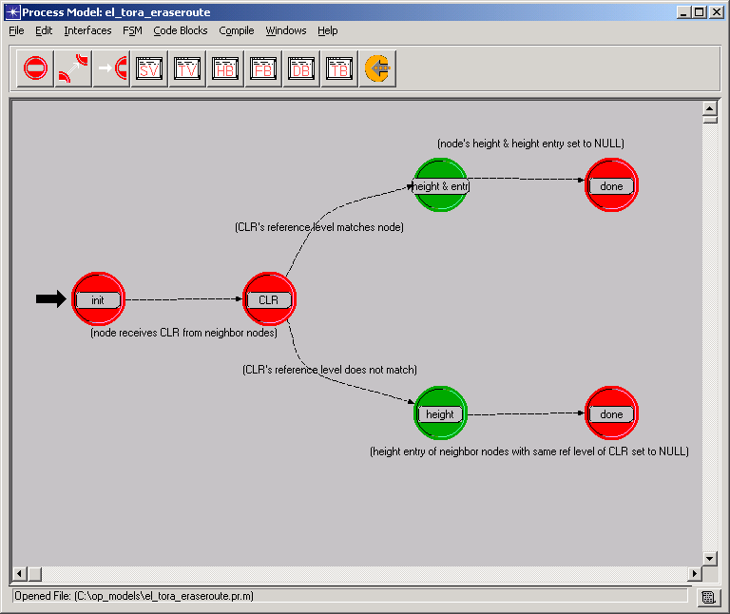

Figure 6.8. Process Model of Erasing Route in TORA

Section 6F. Applicability of TORA

Tactical networking provides perhaps the best example of the environment in which TORA was designed to operate. Although a fixed infrastructure with hardwired links may form some parts of a networking architecture, significant portions of the network/internetwork will likely comprise mobile platforms and rely on wireless communications. This is especially true of far-forward tactical networking, where there will likely be little or no fixed infrastructure.

The architectural design of a tactical network/internetwork will largely determine where TORA is most applicable. In an architecture, where many of the mobile platforms have internal Local Area Networks (LANs) and are interconnected via wireless communications, TORA may be applicable as an internetowk routing solution. If many of the mobile routers have multiple wireless interfaces based on different wireless communications technology, this solution can also serve to bind together the heterogeneous wireless communications infrastructure.

There is also the potential to apply TORA to an individual multihop wireless LAN that is based on a single wireless communications technology. Such a wireless LAN may or may not be part of a larger internetwork. In this case, TORA could essentially by applied at the Media Access Control (MAC) level, to provide a multihop forwarding capability within the LAN.

Section 6G. TORA Conclusions

TORA is a highly adaptive distributed routing algorithm, which has been tailored for operation in mobile networking environment. In its design the ability to perform a shortest path routing computation is sacrificed for a greater ability to limit the scope of control messaging (following link failures and additions) to a small set of nodes near the change. This behavior makes it scalable, adaptive and well suited for a dynamic mobile network with limited bandwidth. The validity of this design choice is supported by simulation results, which indicate that the performance of TORA exceeds that of ILS – a well known and proven technology for supporting shortest path routing – for the conditions expected in a relatively large mobile networks.

TORA is directly applicable to the tactical networking environment, and can provide either an inter-network routing solution or a multi-hop wireless LAN routing solution. In fact, tactical networking provides perhaps he best example of the environment in which TORA was designed to operate. Due to the scalability of the protocol, TORA may be able to support larger routing domains within the networking architecture – thus, relaxing the range of mobility restrictions on the mobile platforms within a given routing domain. Furthermore, using a small number of larger routing domains may also serve to reduce the complexity of the networking architecture. Overall, TORA has the potential to play an important role in the tactical networking environment.

Section 6H. Basic Terminology

- MANET router or router –
A device, identified by a unique router ID (RID), that executes a MANET routing protocol and, under the direction of which, forwards IP packets. It may have multiple interfaces, each identified by an IP address. Associated with each interface is a physical layer communication device. These devices may employ wireless or hardwired communications, and a router may simultaneously employ devices of differing technologies. For example, a MANET router may have four interfaces with differing communications technologies: two hardwired (ethernet and FDDI) and two wireless (spread spectrum and impulse radio).

- Adjacency –
The name given to an “interface on a neighboring router”

- Medium –
A communication channel such as free space, cable or fiber through which connections are established.

- Communication Technology –
The means employed by two devices to transfer information between them.

- Connection –
A physical layer connection, which may be through a wired or wireless medium, between a device attached to an interface of one MANET router and a device utilizing the same communications technology attached to an interface on another MANET router. From the perspective of a given router, a connection is a (interface, adjacency) pair.

- Link –
A logical connection consisting of the logical union of one or more connections between two MANET routers. Thus, a link may consist of a heterogeneous combination of connections through differing media using different communications technologies.

- Neighbor –
From the perspective of a given MANET router, a neighbor is any other router to which it is connected by a link.
- Topology –
A network can be viewed abstractly as a graph whose topology at any point in time is defined by set of points connected by edges.

- Physical Layer Topology –
A topology consisting of connections (the edges) through the same communication medium between devices (the points) communicating using the same communication technology

- Network Layer Topology –
A topology consisting of links (the edges) between MANET routers (the points) which is used as the basis for MANET routing. Since links are the logical union of physical layer connections, it follows that the network layer topology is the logical union of the various physical layer topology.

PART 7. Cluster-Based Algorithm for Dynamic Network Routing

The cluster approach is a routing algorithm which main objective is to replace individual nodes (mobile hosts) with a cluster (a group of mobile hosts) in an attempt to lower overhead during topology changes. The overall procedure of this algorithm is to divide the graph into a number of overlapping clusters. A change in the overall topology will result in a change in cluster membership.

There exist two basic algorithms in this routing scheme. These include both the creation of clusters as well as the maintenance of existing clusters. In a wireless environment there is a great deal of traffic, occurring from the transmission of other data packets or the broadcast information sent from each host in a repeated manner. Maintenance of clusters is critical in operating a dynamic wireless network, as previously mentioned.

Nodes or mobile hosts of any network environment, static or dynamic, are organized into graphs. Graphs may contain any number of nodes. In the cluster-based approach, each node has a list of neighbors, of clusters it belongs to, and a list of boundary nodes in the network. Boundary nodes are the connection from one cluster to another. Clusters are created through a procedure, which will be discussed in depth later. These clusters are formally defined as follows:

- A k-cluster is defined by a subset of nodes, each mutually reachable by a path of at most length k
- The size of cluster C, S(C), is the number of nodes in cluster C
- The edges of a cluster are the edges between the nodes that are members of the cluster
- A graph is cluster-connected, if:
  - The union of clusters covers the whole graph
  - A connected graph exists when a path from each node to every other node through the edges of the clusters in the graph
- Cluster set, S_{n}, is the set of all clusters where n is a member
- A redundant cluster is defined as a cluster, if removed, that does not effect the connection between a pair
- A boundary node is a member of more than one cluster

There are four main topology changes that are accounted for in the cluster-based approach. These changes can be described using two hosts, H_{a} and H_{b}. The first topology change occurs when H_{a} turns on and therefore joins a cluster. Conversely, another change occurs when H_{a} turns off and is excluded from the graph and its node is deleted. The other two topology changes concern the connection and disconnection of nodes. When H_{a} connects to H_{b}, a new edge in the graph is created, and when H_{a} disconnects from H_{b}, an edge is removed from the graph. Figure 7.1 and Figure 7.2 displays the changes in the graph and clusters when node 5 is added and removed from the graph.

Figure 7.1 H₅ Turns ON in this Graph

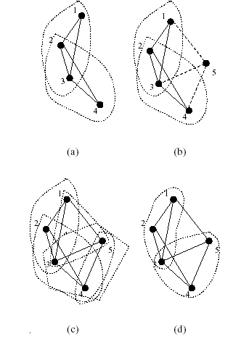

Figure 7.2 H₅ Turns OFF in this Graph

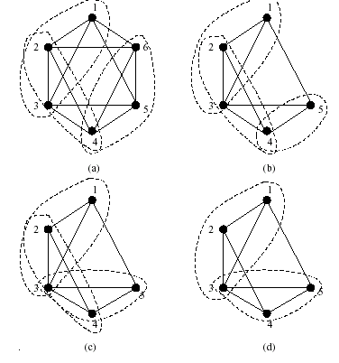
There are main procedures associated with topology changes in the network. These procedures are included in the Appendix (Figure i-ii). One is the Switch ON procedure and the other, Switch OFF. When two hosts connect, the node with the largest identifier, a cluster related statistic, executes the Switch ON scenario, and the other node acts as a neighbor. When two hosts disconnect, if the two nodes were not clustermates, no change in clusters occurs, otherwise the Switch OFF procedure is executed.

In the development of this algorithm, a few important data structures were created to efficiently store appropriate values. One such structure is the cluster list, Clus_List. This list provides the mapping between the clusters and the members. It contains all essential information about the graph and its clusters. Another data structure is the boundary node list, Bound_List. This list keeps track of all the boundary nodes between overlapping clusters. It is the key component for message packet relay as well as broadcast updates.

As mentioned previously cluster maintenance is critical in the operation of a dynamic wireless network. After a change in the topology of a graph or network, each node contains certain information located in the Clus_List and Bound_List structures. Very often propagation delays and network partitions may result in all the nodes of the network having inconsistent data. The usage of clusters eliminates some of this inconsistency. Instead of the source node broadcasting an update to each of the nodes in the network, it is only necessary to send this information to the boundary nodes. Each boundary node is then responsible for relaying the data to the other nodes in its clusters. For example, in the graph in Appendix Figure xiii, when node 5 is added, the cluster procedure is executed and node 5 needs to only broadcast to node 3, the sole boundary node in this graph.

The performance of the Cluster-Based approach is measured using a few specific metrics. These metrics include time complexity, communication complexity, routing overhead, and the number of boundary nodes in a graph. The time complexity is defined as the number of steps it takes for a network to forma after a topology change. Communication complexity measures the number of messages required to form this new network. The routing overhead is the ratio of the path length between a source and a destination.

PART 8. Using OPNET Modeler to Model The Cluster-Based
Approach to Dynamic Network Routing

Section 8A. Design Overview

As discussed in Part 2, the OPNET Modeler has several editors and models that can be used to simulate and design a wireless network environment. The Process Model was used to design and establish a finite state machine for the dynamic cluster routing algorithm. The Node Model was used to design a simple wireless LAN interface, using just transmitters and receivers to relay message packets and broadcast updates. At the top-level the Network Model encapsulates all this information in a subnetwork of communication nodes and links.

In our implementation of this algorithm, we first determined an overall schematic. As illustrated through our extensive use and testing with the OPNET Modeler Tutorials, optimal and efficient design is created from the most internal hierarchical level upwards. Starting with the declaration of data structures and behavioral models, defining the functionality of the processes. Therefore, these processes can be easily implemented into the appropriate node modules.

Section 8B. Design Specifications

The Cluster-Based algorithm is very specific and detailed in its behavior and processes. For simplicity sake, we implemented a layered process model. As stated, the four basic topology changes of this dynamic algorithm are defined as, a host switching ON, switching OFF, connecting to another host, and disconnecting from another host. The outer lay of the Process Model consists of a state diagram that determines in the initial state which of the four topology changes have occurred. If the node has undergone a connection or disconnection, an intermediary state for each scenario must be performed to determine whether any other computations need to be performed, setting the appropriate conditions, or if no cluster changes are necessary. This decision tree is illustrated in Appendix (Figure vii).

The basic procedure for the Switch ON as defined in the Appendix (Figure i), can be implemented using a series of states and transitions. Depending on a series of conditions, appropriate states are executed. The Switch ON Process Model is displayed in the Appendix (Figure viii).

Just as the Switch ON procedure, the Switch OFF procedure as defined in the Appendix (Figure ii), can implemented using a series of states and transitions. This Process Model is illustrated in the Appendix (Figure ix).

After the Process Models were created these behavioral models could be implemented into a Node Model. As explained above, the Node Model may consist of a variety of objects, each with its own unique functionality. For a wireless LAN project, the Node Model can be implemented using a combination of a MAC sublayer and various Internet protocol components. This Node Model is illustrated in the Appendix (Figure vi).

The Network Model was then created using the nodes defined by the Node Model and Process Model. This design consists of a graph of mobile nodes. As explained, the Node Model defines the internal structure of the communication nodes used in the Network Model. The Neighbor List defines its links and the graph’s edges. For simplicity, the graph is displayed as one collective subnetwork. The sample Network Model that was developed for this project is illustrated in the Appendix (Figure x).

Section 8C. C Language Implementation of the Cluster-Based Algorithm

The low-level of the OPNET Modeler is written in the C programming language with the integration of an extensive OPNET library package. The behavior of the Process Model is simply defined in the C language. With the immense learning curve of the OPNET library packages, we opted to simulate this complex algorithm in a C environment. Studying the overall functionality of the Switch ON and Switch OFF procedures as well as their internal functions’ algorithms produced a general understanding of the algorithm and allowed for us to produce a routing simulation.

Examining the procedures in the Appendix (Figure i and Figure ii), it is evident that three main functions concerning node creation exist. These functions are CreateClusters, FindEssential, and FindRedundant. The pseudocodes for these three algorithms are included in the Appendix (Figure iii-v).

The C program for the development of this algorithm is included in the Appendix (Figure xi). The C code defines and uses two main data structures to simulate the Cluster-Based Algorithm. These data structures are a ClusterList (many instances of this used in the manipulation of nodes) and a NeighborList. Both data structures contain similar functionality, including variables to maintain arrays of nodes and counters to keep track of the number of nodes and clusters stored. Both of these list types are declared globally to simulate the concept of being known data to all processes of each node.

The CreateCluster function, as described in the pseudocode, takes as its input parameter, the node Id of the node that has caused the topology, whether it is turning on or a new connection has been formed. Using this node Id, it creates all existing clusters in the graph that include it. This is implemented using a series of looping functionality on the NeighborList. The main criterion for forming new clusters is that all neighbors of the node Id and the node Id itself creates a cluster. Also, all other nodes that are neighbors to both the node Id and neighbor form clusters. The other creation scenario is defined as all neighbors of each of the NeighborList for the neighbor of the node Id form clusters. All these existing clusters are stored in a Clus_List data structure.

The FindEssential function, takes as it input parameter the node Id as well. The main objective of this function is to eliminate as much redundancy as possible as well as to ensure that no node, other than the node Id, exist in more than one “essential” cluster. The function uses the globally declared and initialized Clus_List structure that is formed in the CreateCluster function. For each existing cluster, a reiterative collection of loops executes a search for whether the nodes of the cluster, which is not the node Id, exist within any other “essential” class. If this is the case, the cluster containing this node is marked “non-essential.” The resulting list is stored in a new instantiation of Clus_List.

The third of the main functions for these procedures includes the design and implementation of FindRedundant. The addition of the essential clusters may make one or more existing clusters redundant. Determining whether or not the cluster-connectivity between any pair of nodes is affected due to the removal of a cluster performs the search and elimination of redundant clusters. If no effect ensues, the cluster is marked as redundant.

In an actual dynamic wireless network the final Bound_List and Clus_List, after undergoing formation and manipulation by the three functions, is broadcast to all neighbors allowing them to update their own data structures.

Section 8D. Code and Simulation Results

The C programming code can be found in the Appendix (Figure xi). This code designs a small Cluster-Based Dynamic Wireless routing simulation. Using a main tester function, a variety of topology changes are simulated and the resulting clusters are formed. A file of simulation results is included in the Appendix (Figure xii) as well as a small example of results shown below in Figure 8.1. In this figure, a sample network is displayed. Given the node 0, a list of possible clusters, essential clusters, and non-redundant clusters are formed.

Figure 8.1 Sample of Simulation Results and Cluster Formations

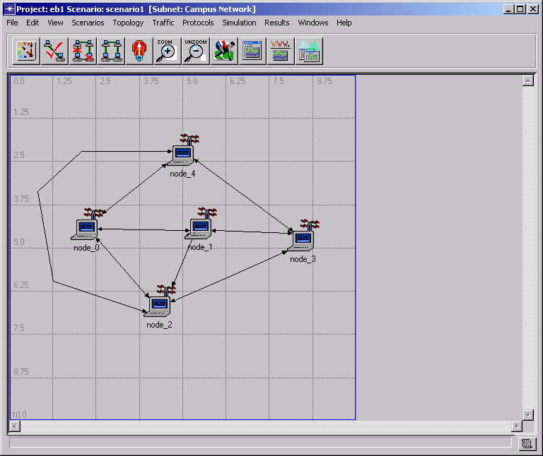
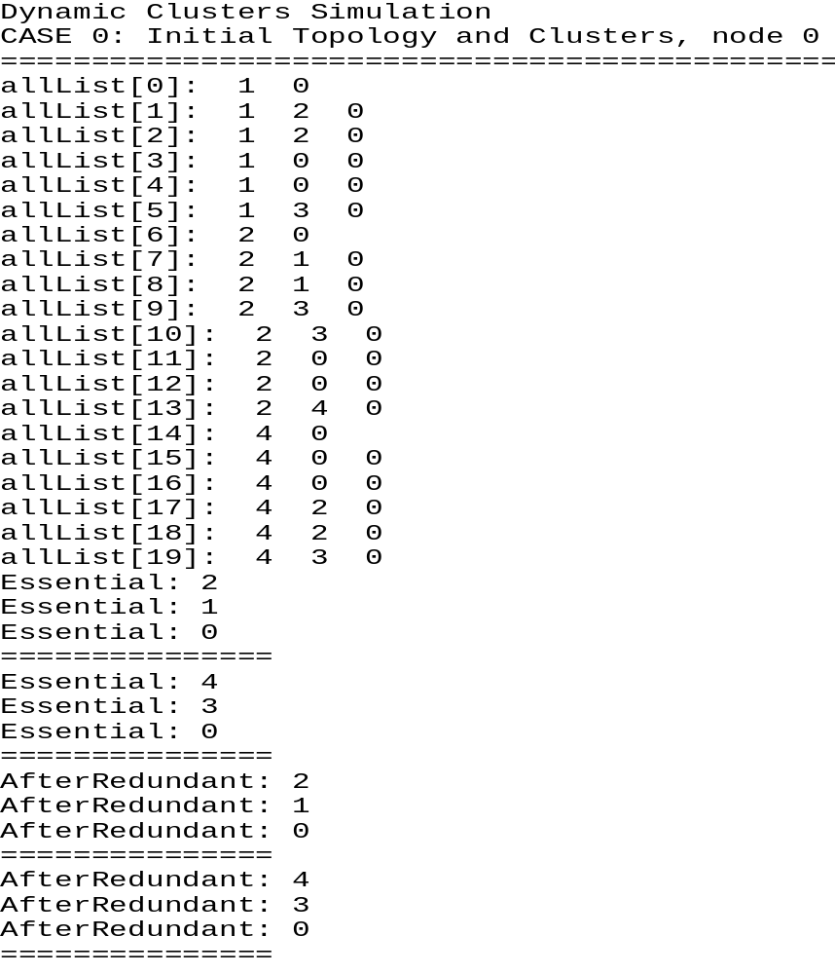

Section 8E. Analysis of Results

In the design and implementation process of our CreateCluster, FindEssential, and FindRedundant functions, some comments on the overall procedures have been formed. In a real-time Cluster-Based Approach routing environment a more complex amount of data is typically used to create cluster membership. The main objective of the FindRedundant function is to use an already existing list of clusters from before the topology change and compare and eliminate any redundant clusters from those that had newly been formed. For simplicity, this large amount of data a test-case complexity was eliminated from our design and simulation.

Also, it should be pointed out that cluster membership is highly dependent on the order in which the NeighborList is initially entered and evaluated. Because the clusters are formed in order of the lists, there was evidence that a slight manipulation of this data caused different essential clusters for the same graph of nodes.

Overall, the simulation data that was collected was expected. There were apparent advantages and disadvantages to this algorithm. An advantage is that there is a large decrease in the amount of broadcast updates that need to be transmitted. Also, there is less complexity in combining the data of all nodes into a series of cluster structures. A disadvantage is that a node may lose its identity when used to create a cluster. When there is a topology change in the graph concerning this node, it is to be made sure that an individual’s node data is maintained so it can be used at that time.

IV. Errors of Uncertainty, Obstacles, and Roadblocks

Over the past months spent working on this project, our overall scope and objective has been redefined on several occasions. Our initial intent was to use the OPNET Modeler to simulate a list of several wireless routing algorithms. Unfortunately, the learning curve associated with the OPNET Modeler and its extensive models, editors, and library functions, was great. Our objective was eventually narrowed and defined to its current status.

A large obstacle in our design and use of the OPNET Modeler was a problem with the initial installation of this software program. We encountered a series of license issues as well as administrative privilege issues.

Sources
- OPNET Technologies, Inc. OPNET Modeler Documentation. 2002
- Vincent D. Park, Joseph P. Macker and M. Scott Corson,
Applicability of the Temporally Ordered Routing Algorithm for use in Mobile Tactical Networks, Information Technology Division Naval Research Laboratory, Washington, DC; Institute for Systems Research University of Maryland, College Park, MD
- Vincent D. Park and M. Scott Corson,
Temporally Ordered Routing Algorithm (TORA), IETF MANET Working Group, Flarion Technologies, Inc. Bedminster, NJ (January 2002)
- Vincent D. Park and M. Scott Corson,
A Highly Adaptive Distributed Routing Algorithm for Mobile Wireless Networks, Proceedings of IEEE INFOCOM ’97, Kobe, Japan (April 1997)
- Krishna, P., Vaidya, N. H., Chatterjee M., Pradham, D. K., A Cluster-Based Approach for Routing in Dynamic Networks. ACM SIGCOMM, Computer Communication Review (http://www.acm.org/sigcomm/ccr/archive/1997/apr97/ccr-9704-krishna.pdf)
- www.opnet.com

APPENDIX

FIGURE i. Procedure for the Switch ON Procedure in Dynamic Cluster Routing

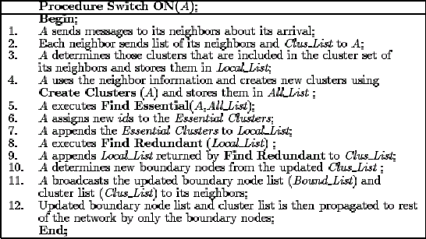

FIGURE ii. Procedure for the Switch OFF Procedure in Dynamic Cluster
Routing

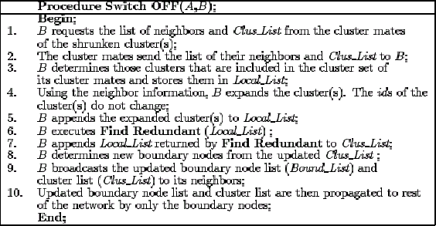

FIGURE iii. Pseudocode for the CreateCluster(A) Function

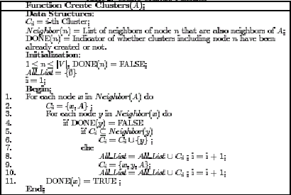

FIGURE iv. Pseudocode for the FindEssential(A) Function

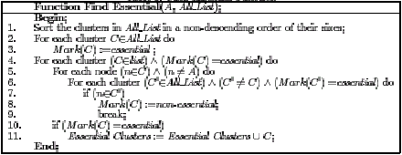

FIGURE v. Pseudocode for the FindRedundant(A) Function

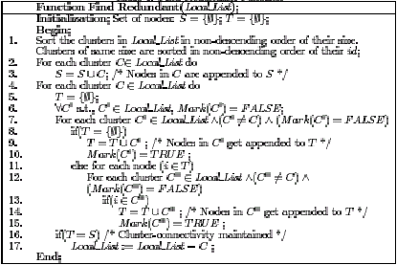

FIGURE vi. Node Model for a Wireless LAN

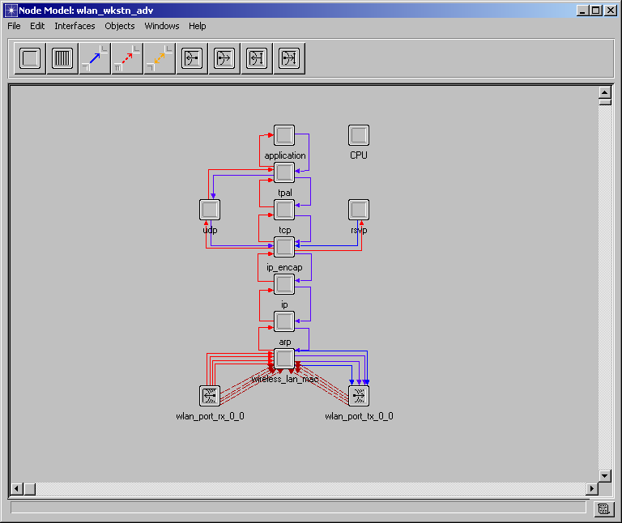

FIGURE vii. Process Model. Cluster-Based Approach
Decision Tree: Switch ON or Switch OFF
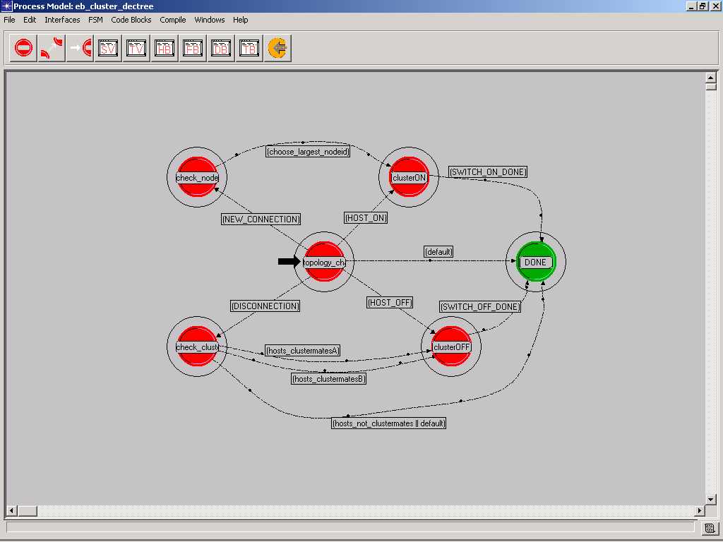

FIGURE viii. Process Model. Cluster-Based Approach
Switch ON Procedure

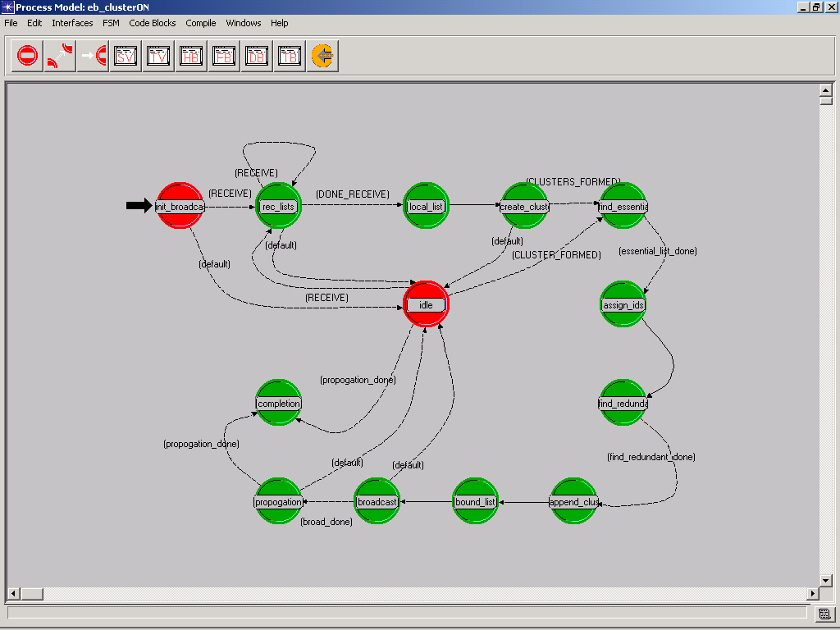

FIGURE ix. Process Model. Cluster-Based Approach
Switch OFF Procedure
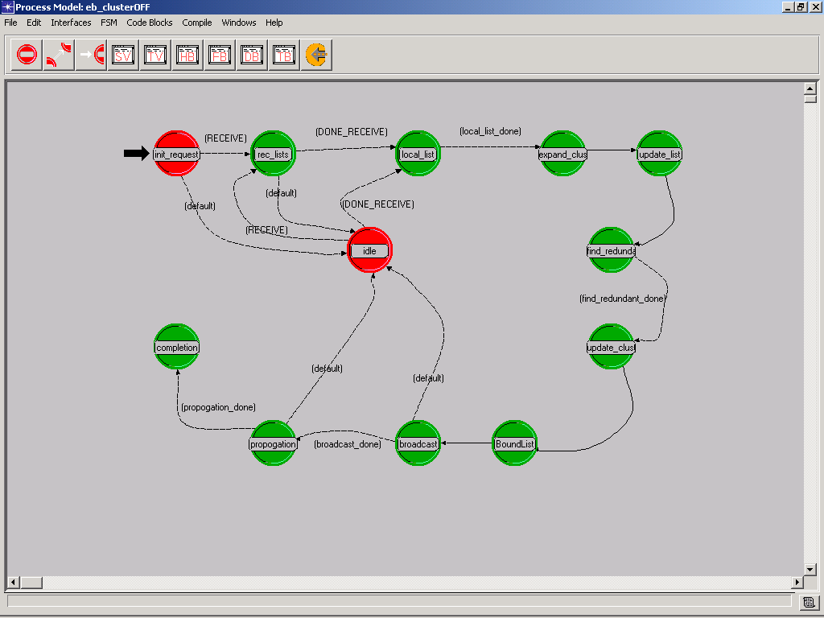

FIGURE x. Network Model. Cluster-Based Approach
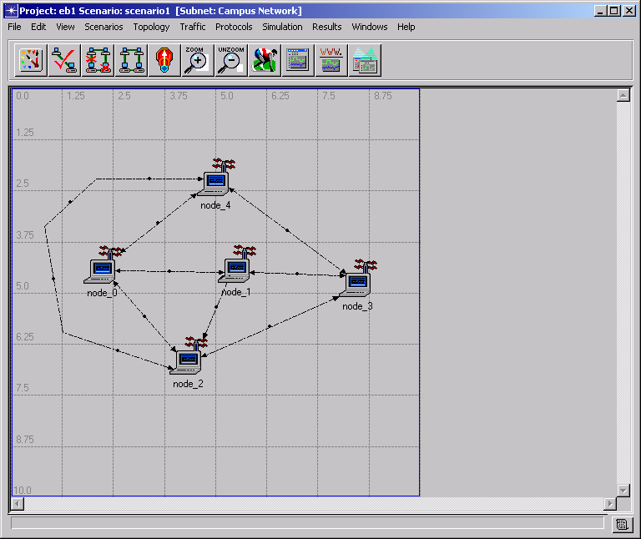

FIGURE xi. Cluster-Based Approach
Implementation: C Language Code

FIGURE xii. Cluster Based-Approach
Implementation: Simulation Output File

FIGURE xiii. Cluster-Based Approach
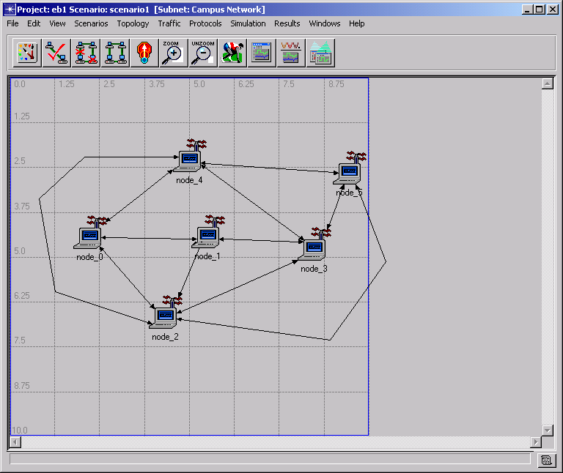
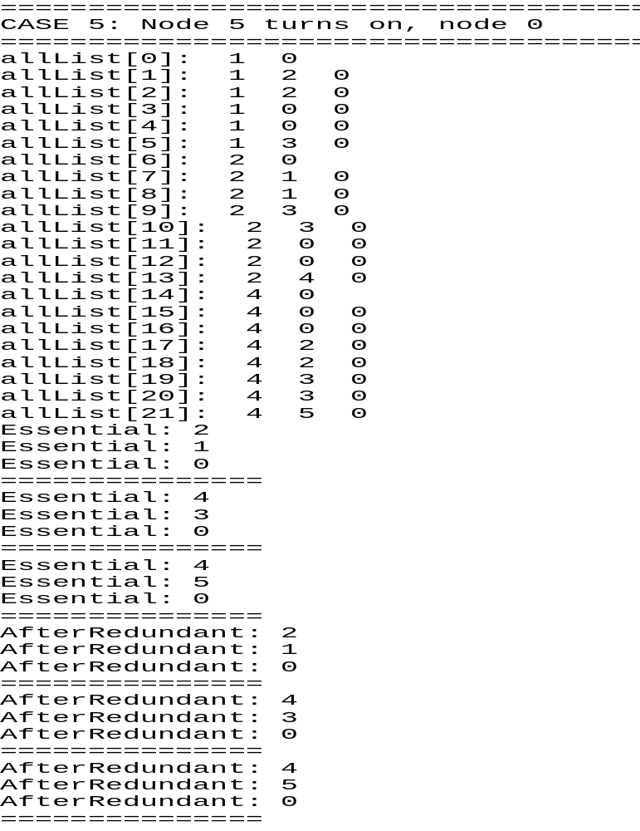Simulation Results: H₅ Turns ON, nodeID =0

FIGURE xiv. Cluster-Based Approach
Simulation Results: H₂ OFF, nodeID = 5



