Tufts University
School of Engineering
Department of Electrical and Computer Engineering


EE 194 Wireless Sensor Networks
Spring 2005

“RFID Security”

Name: Anthony Arous
Vincent Yu
Submitted To: Prof. Hwa Chang
Report Due: May 5, 2005

Table of Contents
Table of Contents 2
Background Information 3
Research 4
Security Background 4
Current Technology 4
Attack Methods 4
Encryption Techniques 5
Data Encryption Standard (DES) 5
In Depth 5
Key Scheduling 5
Plaintext Preparation 7
DES Core Function 9
Tables Used in the DES Core Function 10
How to Use the S-Boxes 13
Ciphertext Preparation 14
Encryption and Decryption 14
Triple DES 14
Advanced Encryption Standard (AES) 15
In Depth 15
The Steps 15
The SubBytes Step 16
The shiftRows Step 16
The MixColumns Step 17
The AddRoundKey Step 18
The Future of AES 18
Protection Mechanisms 19
Juels-Pappu Banknote Protection Scheme 19
Preliminary Discussion 19
Requirements 19
Encryption Process 20
Initial Banknote Creation 20
Re-Encryption 20
Tracing 21
Effectiveness 21
Re-Encryption 21
Public Access Key 22
ElGamal Encryption Scheme 22
Conclusions 22
References 23
Appendix 24

Background Information
In today’s world, radio frequency identification (or RFID) is becoming a very popular form of wireless communication via small sensors, such as those found in Exhibits 1 and 2 of the Appendix. One of the primary advantages of these tags is the low cost. Most RFIDs can be purchased for approximately five to ten cents each. These tags can also serve many different purposes, from personal identification or transmitting medical data. Figure 1 below shows how the data is transferred between the tags and specialized scanners. Typically, there is no standard security method, but Figure 1 does identify the communication used in medical applications.

Figure 1: Tag-Scanner Communication (with Secured Registry)
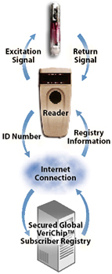

The following list highlights some of the current applications for RFID technology.
▪ ATM: Scanning of the sensor replaces the use of a card and passcode.
▪ Vending Machines: Change and paper money becomes unnecessary. By scanning the sensor, the machine will be able to charge an account automatically.
▪ Security: By customizing the scanners, specific areas can be restricted to people with appropriate security clearance. In addition, devices can also be modified to work with some people.
▪ Tracking: Sensors may be implanted in people or objects, so they may be discovered by a scanner when passing by one. This method is used to track patients, prisoners, or inventory.
▪ Medicine: RFIDs can be modified to be able to monitor vital signs, such as heart rate and oxygen levels. Other devices have been customized to replace standard diabetes monitors.

Research

Security Background
Having a secure data encryption scheme is crucial to the privacy of the information being transmitted via RFID. It is important to integrate any future devices with encryption to keep people for gaining access to important data. Currently many RFID devices are equipped with an unpublished 40-bit cipher code created by Texas Instruments (TI). Although it was a good security feature at the time, technology advances have proven that it is necessary to use an encryption of a longer length.

Current Technology
The 40-bit Texas Instrument cipher code has been widely used in the Digital Signature Transponders (DST) which are used in immobilizer keys and the ExxonMobil Speedpass, as seen in Exhibit 3 of the Appendix, just to name a few. In many of the Ford automobiles released in 2005, over 150 million vehicles are equipped with a device that exists within the key. Once the correct key goes near the ignition, it will allow the car to start; otherwise the car will not start. And with the Speedpass, swiping the device near the receiver at the gas pump will connect to your credit card as to make paying for gas easier and quicker. But these devices can been cracked within minutes with the right equipment, allowing others to either continue to steal your car or use your credit card. Exhibits 4 and 5 in the Appendix show some hardware examples of how the technology was defeated.
A DST consists of a small microchip and antenna coil encapsulated in a plastic or glass capsule. It is a passive device, which is to say that it does not contain an on-board source of power, but rather receives its power from the interrogation signal transmitted by the reading device via electromagnetic inductance. This design choice allows for a compact design and long transponder life.
A DST contains a secret, 40-bit cryptographic key which is field-programmable via RF command. In its interaction with a reader, a DST emits a factory-set (24-bit) identifier, and then authenticates itself by engaging in a challenge-response protocol. The reader initiates the protocol by transmitting a 40-bit challenge. The DST encrypts this challenge under its key and returns a 24-bit response. It is thus the secrecy of the key that ultimately protects the DST against cloning and simulation.

Attack Methods
There are effectively two different methods by which an attacker may harvest signals from a target DST, and two different corresponding physical ranges. The first mode of attack is active scanning: The attacker brings a reader in her control within scanning range of the target DST. DSTs of the type found in SpeedPass and automobile ignition keys are designed for short range scanning - on the order of a few centimeters. In practice, however, a longer range is achievable. In preliminary experiments, an effective range of several inches for a DST on a keyring in the pocket of a simulated victim using a tiny antenna can be achieved. A DST may respond to as many as eight queries per second. Thus, it is possible to perform the two scans requisite for our simulation attacks in as little as one-quarter of a second. At the limit of the range achievable by a given antenna, however, scanning becomes somewhat unreliable, and can require more time.
The second mode of attack is passive eavesdropping. Limitations on the effective range of active scanning stem from the requirement that a reader antenna furnish power to the target DST. An attacker might instead eavesdrop on the communication between a legitimate reader and a target DST during a valid authentication session. In this case, the attacker need not furnish power to the DST; the effective eavesdropping range then depends solely on the ability to intercept the signal emitted by the DST. The U.S. Department of Homeland Security reports successful eavesdropping of this kind on 13.56 Mhz tags at a distance of some tens of feet. The DST, however, operates at 134 kHz. Signals at this considerably lower frequency penetrate obstacles more effectively, which may facilitate eavesdropping; on the other hand, larger antennas are required for effective signal interception.

Encryption Techniques
The most straightforward architectural fix to the problems we describe here is simple: Increase the length of the encryption. It would be beneficial to the security of the devices to look into schemes such as Data Encryption Standard (DES), Triple DES or the Advanced Encryption Standard (AES). DES contains a 64-bit key (56-bit effective), the Triple DES 192-bit (168-bit effective) and the AES is 128-bit.

Data Encryption Standard (DES)
The DES algorithm specification was published in January 1977, and with the official backing of the government it became a very widely employed algorithm in a short amount of time. Unfortunately, over time various shortcut attacks were found that could significantly reduce the amount of time needed to find a DES key by brute force. And as computers became progressively faster and more powerful, it was recognized that a 56-bit key was simply not large enough for high security applications. As a result of these serious flaws, NIST abandoned their official endorsement of DES in 1997 and began work on a replacement, to be called the Advanced Encryption Standard (AES). Despite the growing concerns about its vulnerability, DES is still widely used by financial services and other industries worldwide to protect sensitive on-line applications.

In Depth
DES encrypts and decrypts data in 64-bit blocks, using a 64-bit key (although the effective key strength is only 56 bits, as explained below). It takes a 64-bit block of plaintext as input and outputs a 64-bit block of ciphertext. Since it always operates on blocks of equal size and it uses both permutations and substitutions in the algorithm, DES is both a block cipher and a product cipher.
DES has 16 rounds, meaning the main algorithm is repeated 16 times to produce the ciphertext. It has been found that the number of rounds is exponentially proportional to the amount of time required to find a key using a brute-force attack. So as the number of rounds increases, the security of the algorithm increases exponentially.

Key Scheduling
Although the input key for DES is 64 bits long, the actual key used by DES is only 56 bits in length. The least significant (right-most) bit in each byte is a parity bit, and should be set so that there are always an odd number of 1s in every byte. These parity bits are ignored, so only the seven most significant bits of each byte are used, resulting in a key length of 56 bits.
The first step is to pass the 64-bit key through a permutation called Permuted Choice 1, or PC-1 for short. The table for this is given below. Note that in all subsequent descriptions of bit numbers, 1 is the left-most bit in the number, and n is the rightmost bit.

Table 1: Permuted Choice 1 for DES Encryption
PC-1: Permuted Choice 1
Bit | 0 | 1 | 2 | 3 | 4 | 5 | 6
1 | 57 | 49 | 41 | 33 | 25 | 17 | 9
8 | 1 | 58 | 50 | 42 | 34 | 26 | 18
15 | 10 | 2 | 59 | 51 | 43 | 35 | 27
22 | 19 | 11 | 3 | 60 | 52 | 44 | 36
29 | 63 | 55 | 47 | 39 | 31 | 23 | 15
36 | 7 | 62 | 54 | 46 | 38 | 30 | 22
43 | 14 | 6 | 61 | 53 | 45 | 37 | 29
50 | 21 | 13 | 5 | 28 | 20 | 12 | 4

For example, we can use the PC-1 table (Table 1 above) to figure out how bit 30 of the original 64-bit key transforms to a bit in the new 56-bit key. Find the number 30 in the table, and notice that it belongs to the column labeled 5 and the row labeled 36. Add up the value of the row and column to find the new position of the bit within the key. For bit 30, 36 + 5 = 41, so bit 30 becomes bit 41 of the new 56-bit key. Note that bits 8, 16, 24, 32, 40, 48, 56 and 64 of the original key are not in the table. These are the unused parity bits that are discarded when the final 56-bit key is created.
Now that we have the 56-bit key, the next step is to use this key to generate 16 48-bit subkeys, called K[1]-K[16], which are used in the 16 rounds of DES for encryption and decryption. The procedure for generating the subkeys - known as key scheduling - is fairly simple:

1. Set the round number R to 1.
2. Split the current 56-bit key, K, up into two 28-bit blocks, L (the left-hand half) and R (the right-hand half).
3. Rotate L left by the number of bits specified in the table below, and rotate R left by the same number of bits as well.
4. Join L and R together to get the new K.
5. Apply Permuted Choice 2 (PC-2) to K to get the final K[R], where R is the round number we are on.
6. Increment R by 1 and repeat the procedure until we have all 16 subkeys K[1]-K[16].

Tables 2 and 3 below are the tables involved in these operations:

Table 2: Subkey Rotation Table for DES
Subkey Rotation Table
Round Number | 1 | 2 | 3 | 4 | 5 | 6 | 7 | 8 | 9 | 10 | 11 | 12 | 13 | 14 | 15 | 16
Number of bits to rotate | 1 | 1 | 2 | 2 | 2 | 2 | 2 | 2 | 1 | 2 | 2 | 2 | 2 | 2 | 2 | 1

Table 3: Permuted Choice 2 for DES

PC-2: Permuted Choice 2
Bit | 0 | 1 | 2 | 3 | 4 | 5
1 | 14 | 17 | 11 | 24 | 1 | 5
7 | 3 | 28 | 15 | 6 | 21 | 10
13 | 23 | 19 | 12 | 4 | 26 | 8
19 | 16 | 7 | 27 | 20 | 13 | 2
25 | 41 | 52 | 31 | 37 | 47 | 55
31 | 30 | 40 | 51 | 45 | 33 | 48
37 | 44 | 49 | 39 | 56 | 34 | 53
43 | 46 | 42 | 50 | 36 | 29 | 32

Plaintext Preparation
Once the key scheduling has been performed, the next step is to prepare the plaintext for the actual encryption. This is done by passing the plaintext through a permutation called the Initial Permutation, or IP for short. This table also has an inverse, called the Inverse Initial Permutation, or IP^(-1). Sometimes IP^(-1) is also called the Final Permutation. Both of these tables are shown below as Tables 4 and 5.

Table 4: Initial Permutation for DES
IP: Initial Permutation
Bit | 0 | 1 | 2 | 3 | 4 | 5 | 6 | 7
1 | 58 | 50 | 42 | 34 | 26 | 18 | 10 | 2
9 | 60 | 52 | 44 | 36 | 28 | 20 | 12 | 4
17 | 62 | 54 | 46 | 38 | 30 | 22 | 14 | 6
25 | 64 | 56 | 48 | 40 | 32 | 24 | 16 | 8
33 | 57 | 49 | 41 | 33 | 25 | 17 | 9 | 1
41 | 59 | 51 | 43 | 35 | 27 | 19 | 11 | 3
49 | 61 | 53 | 45 | 37 | 29 | 21 | 13 | 5
57 | 63 | 55 | 47 | 39 | 31 | 23 | 15 | 7

Table 5: Inverse Initial Permutation for DES

IP^(-1): Inverse Initial Permutation
Bit | 0 | 1 | 2 | 3 | 4 | 5 | 6 | 7
1 | 40 | 8 | 48 | 16 | 56 | 24 | 64 | 32
9 | 39 | 7 | 47 | 15 | 55 | 23 | 63 | 31
17 | 38 | 6 | 46 | 14 | 54 | 22 | 62 | 30
25 | 37 | 5 | 45 | 13 | 53 | 21 | 61 | 29
33 | 36 | 4 | 44 | 12 | 52 | 20 | 60 | 28
41 | 35 | 3 | 43 | 11 | 51 | 19 | 59 | 27
49 | 34 | 2 | 42 | 10 | 50 | 18 | 58 | 26
57 | 33 | 1 | 41 | 9 | 49 | 17 | 57 | 25

These tables are used just like PC-1 and PC-2 were for the key scheduling. By looking at the table is becomes apparent why one permutation is called the inverse of the other. For example, let's examine how bit 32 is transformed under IP. In the table, bit 32 is located at the intersection of the column labeled 4 and the row labeled 25. So this bit becomes bit 29 of the 64-bit block after the permutation. Now let's apply IP^(-1). In IP^(-1), bit 29 is located at the intersection of the column labeled 7 and the row labeled 25. So this bit becomes bit 32 after the permutation. And this is the bit position that we started with before the first permutation. So IP^(-1) really is the inverse of IP. It does the exact opposite of IP. If you run a block of plaintext through IP and then pass the resulting block through IP^(-1), you'll end up with the original block.

DES Core Function
Once the key scheduling and plaintext preparation have been completed, the actual encryption or decryption is performed by the main DES algorithm. The 64-bit block of input data is first split into two halves, L and R. L is the left-most 32 bits, and R is the right-most 32 bits. The following process is repeated 16 times, making up the 16 rounds of standard DES. We call the 16 sets of halves L[0]-L[15] and R[0]-R[15].

1. R[I-1] - where I is the round number, starting at 1 - is taken and fed into the E-Bit Selection Table, which is like a permutation, except that some of the bits are used more than once. This expands the number R[I-1] from 32 to 48 bits to prepare for the next step.
2. The 48-bit R[I-1] is XORed with K[I] and stored in a temporary buffer so that R[I-1] is not modified.
3. The result from the previous step is now split into 8 segments of 6 bits each. The left-most 6 bits are B[1], and the right-most 6 bits are B[8]. These blocks form the index into the S-boxes, which are used in the next step. The Substitution boxes, known as S-boxes, are a set of 8 two-dimensional arrays, each with 4 rows and 16 columns. The numbers in the boxes are always 4 bits in length, so their values range from 0-15. The S-boxes are numbered S[1]-S[8].
4. Starting with B[1], the first and last bits of the 6-bit block are taken and used as an index into the row number of S[1], which can range from 0 to 3, and the middle four bits are used as an index into the column number, which can range from 0 to 15. The number from this position in the S-box is retrieved and stored away. This is repeated with B[2] and S[2], B[3] and S[3], and the others up to B[8] and S[8]. At this point, you now have 8 4-bit numbers, which when strung together one after the other in the order of retrieval, give a 32-bit result.
5. The result from the previous stage is now passed into the P Permutation.
6. This number is now XORed with L[I-1], and moved into R[I]. R[I-1] is moved into L[I].
7. At this point we have a new L[I] and R[I]. Here, we increment I and repeat the core function until I = 17, which means that 16 rounds have been executed and keys K[1]-K[16] have all been used.

When L[16] and R[16] have been obtained, they are joined back together in the same fashion they were split apart (L[16] is the left-hand half, R[16] is the right-hand half), then the two halves are swapped, R[16] becomes the left-most 32 bits and L[16] becomes the right-most 32 bits of the pre-output block and the resultant 64-bit number is called the pre-output.

Tables Used in the DES Core Function

Table 6: E-Bit Selection Table for DES
E-Bit Selection Table
Bit | 0 | 1 | 2 | 3 | 4 | 5
1 | 32 | 1 | 2 | 3 | 4 | 5
7 | 4 | 5 | 6 | 7 | 8 | 9
13 | 8 | 9 | 10 | 11 | 12 | 13
19 | 12 | 13 | 14 | 15 | 16 | 17
25 | 16 | 17 | 18 | 19 | 20 | 21
31 | 20 | 21 | 22 | 23 | 24 | 25
37 | 24 | 25 | 26 | 27 | 28 | 29
43 | 28 | 29 | 30 | 31 | 32 | 1

Table 7: P Permutation for DES

P Permutation
Bit | 0 | 1 | 2 | 3
1 | 16 | 7 | 20 | 21
5 | 29 | 12 | 28 | 17
9 | 1 | 15 | 23 | 26
13 | 5 | 18 | 31 | 10
17 | 2 | 8 | 24 | 14
21 | 32 | 27 | 3 | 9
25 | 19 | 13 | 30 | 6
29 | 22 | 11 | 4 | 25

Table 8: Substitution Box 1 for DES

S-Box 1: Substitution Box 1
Row / Column | 0 | 1 | 2 | 3 | 4 | 5 | 6 | 7 | 8 | 9 | 10 | 11 | 12 | 13 | 14 | 15
0 | 14 | 4 | 13 | 1 | 2 | 15 | 11 | 8 | 3 | 10 | 6 | 12 | 5 | 9 | 0 | 7
1 | 0 | 15 | 7 | 4 | 14 | 2 | 13 | 1 | 10 | 6 | 12 | 11 | 9 | 5 | 3 | 8
2 | 4 | 1 | 14 | 8 | 13 | 6 | 2 | 11 | 15 | 12 | 9 | 7 | 3 | 10 | 5 | 0
3 | 15 | 12 | 8 | 2 | 4 | 9 | 1 | 7 | 5 | 11 | 3 | 14 | 10 | 0 | 6 | 13

Table 9: Substitution Box 2 for DES

S-Box 2: Substitution Box 2
Row / Column | 0 | 1 | 2 | 3 | 4 | 5 | 6 | 7 | 8 | 9 | 10 | 11 | 12 | 13 | 14 | 15
0 | 15 | 1 | 8 | 14 | 6 | 11 | 3 | 4 | 9 | 7 | 2 | 13 | 12 | 0 | 5 | 10
1 | 3 | 13 | 4 | 7 | 15 | 2 | 8 | 14 | 12 | 0 | 1 | 10 | 6 | 9 | 11 | 5
2 | 0 | 14 | 7 | 11 | 10 | 4 | 13 | 1 | 5 | 8 | 12 | 6 | 9 | 3 | 2 | 15
3 | 13 | 8 | 10 | 1 | 3 | 15 | 4 | 2 | 11 | 6 | 7 | 12 | 0 | 5 | 14 | 9

Table 10: Substitution Box 3 for DES

S-Box 3: Substitution Box 3
Row / Column | 0 | 1 | 2 | 3 | 4 | 5 | 6 | 7 | 8 | 9 | 10 | 11 | 12 | 13 | 14 | 15
0 | 10 | 0 | 9 | 14 | 6 | 3 | 15 | 5 | 1 | 13 | 12 | 7 | 11 | 4 | 2 | 8
1 | 13 | 7 | 0 | 9 | 3 | 4 | 6 | 10 | 2 | 8 | 5 | 14 | 12 | 11 | 15 | 1
2 | 13 | 6 | 4 | 9 | 8 | 15 | 3 | 0 | 11 | 1 | 2 | 12 | 5 | 10 | 14 | 7
3 | 1 | 10 | 13 | 0 | 6 | 9 | 8 | 7 | 4 | 15 | 14 | 3 | 11 | 5 | 2 | 12

Table 11: Substitution Box 4 for DES

S-Box 4: Substitution Box 4
Row / Column | 0 | 1 | 2 | 3 | 4 | 5 | 6 | 7 | 8 | 9 | 10 | 11 | 12 | 13 | 14 | 15
0 | 7 | 13 | 14 | 3 | 0 | 6 | 9 | 10 | 1 | 2 | 8 | 5 | 11 | 12 | 4 | 15
1 | 13 | 8 | 11 | 5 | 6 | 15 | 0 | 3 | 4 | 7 | 2 | 12 | 1 | 10 | 14 | 9
2 | 10 | 6 | 9 | 0 | 12 | 11 | 7 | 13 | 15 | 1 | 3 | 14 | 5 | 2 | 8 | 4
3 | 3 | 15 | 0 | 6 | 10 | 1 | 13 | 8 | 9 | 4 | 5 | 11 | 12 | 7 | 2 | 14

Table 12: Substitution Box 5 for DES

S-Box 5: Substitution Box 5
Row / Column | 0 | 1 | 2 | 3 | 4 | 5 | 6 | 7 | 8 | 9 | 10 | 11 | 12 | 13 | 14 | 15
0 | 2 | 12 | 4 | 1 | 7 | 10 | 11 | 6 | 8 | 5 | 3 | 15 | 13 | 0 | 14 | 9
1 | 14 | 11 | 2 | 12 | 4 | 7 | 13 | 1 | 5 | 0 | 15 | 10 | 3 | 9 | 8 | 6
2 | 4 | 2 | 1 | 11 | 10 | 13 | 7 | 8 | 15 | 9 | 12 | 5 | 6 | 3 | 0 | 14
3 | 11 | 8 | 12 | 7 | 1 | 14 | 2 | 13 | 6 | 15 | 0 | 9 | 10 | 4 | 5 | 3

Table 13: Substitution Box 6 for DES

S-Box 6: Substitution Box 6
Row / Column | 0 | 1 | 2 | 3 | 4 | 5 | 6 | 7 | 8 | 9 | 10 | 11 | 12 | 13 | 14 | 15
0 | 12 | 1 | 10 | 15 | 9 | 2 | 6 | 8 | 0 | 13 | 3 | 4 | 14 | 7 | 5 | 11
1 | 10 | 15 | 4 | 2 | 7 | 12 | 9 | 5 | 6 | 1 | 13 | 14 | 0 | 11 | 3 | 8
2 | 9 | 14 | 15 | 5 | 2 | 8 | 12 | 3 | 7 | 0 | 4 | 10 | 1 | 13 | 11 | 6
3 | 4 | 3 | 2 | 12 | 9 | 5 | 15 | 10 | 11 | 14 | 1 | 7 | 6 | 0 | 8 | 13

Table 14: Substitution Box 7 for DES

S-Box 7: Substitution Box 7
Row / Column | 0 | 1 | 2 | 3 | 4 | 5 | 6 | 7 | 8 | 9 | 10 | 11 | 12 | 13 | 14 | 15
0 | 4 | 11 | 2 | 14 | 15 | 0 | 8 | 13 | 3 | 12 | 9 | 7 | 5 | 10 | 6 | 1
1 | 13 | 0 | 11 | 7 | 4 | 9 | 1 | 10 | 14 | 3 | 5 | 12 | 2 | 15 | 8 | 6
2 | 1 | 4 | 11 | 13 | 12 | 3 | 7 | 14 | 10 | 15 | 6 | 8 | 0 | 5 | 9 | 2
3 | 6 | 11 | 13 | 8 | 1 | 4 | 10 | 7 | 9 | 5 | 0 | 15 | 14 | 2 | 3 | 12

Table 15: Substitution Box 8 for DES

S-Box 8: Substitution Box 8
Row / Column | 0 | 1 | 2 | 3 | 4 | 5 | 6 | 7 | 8 | 9 | 10 | 11 | 12 | 13 | 14 | 15
0 | 13 | 2 | 8 | 4 | 6 | 15 | 11 | 1 | 10 | 9 | 3 | 14 | 5 | 0 | 12 | 7
1 | 1 | 15 | 13 | 8 | 10 | 3 | 7 | 4 | 12 | 5 | 6 | 11 | 0 | 14 | 9 | 2
2 | 7 | 11 | 4 | 1 | 9 | 12 | 14 | 2 | 0 | 6 | 10 | 13 | 15 | 3 | 5 | 8
3 | 2 | 1 | 14 | 7 | 4 | 10 | 8 | 13 | 15 | 12 | 9 | 0 | 3 | 5 | 6 | 11

How to Use the S-Boxes
The purpose of this example is to clarify how the S-boxes work. Suppose we have the following 48-bit binary number:

011101000101110101000111101000011100101101011101
In order to pass this through steps 3 and 4 of the Core Function as outlined above, the number is split up into 8 6-bit blocks, labeled B[1] to B[8] from left to right:
011101 000101 110101 000111 101000 011100 101101 011101

Now, eight numbers are extracted from the S-boxes - one from each box:
B[1] = S[1](01, 1110) = S[1][1][14] = 3 = 0011
B[2] = S[2](01, 0010) = S[2][1][2 ] = 4 = 0100
B[3] = S[3](11, 1010) = S[3][3][10] = 14 = 1110
B[4] = S[4](01, 0011) = S[4][1][3 ] = 5 = 0101
B[5] = S[5](10, 0100) = S[5][2][4 ] = 10 = 1010
B[6] = S[6](00, 1110) = S[6][0][14] = 5 = 0101
B[7] = S[7](11, 0110) = S[7][3][6 ] = 10 = 1010
B[8] = S[8](01, 1110) = S[8][1][14] = 9 = 1001
In each case of S[n][row][column], the first and last bits of the current B[n] are used as the row index, and the middle four bits as the column index.
The results are now joined together to form a 32-bit number which serves as the input to stage 5 of the Core Function (the P Permutation):
00110100111001011010010110101001

Ciphertext Preparation
The final step is to apply the permutation IP^(-1) to the pre-output. The result is the completely encrypted ciphertext.

Encryption and Decryption
The same algorithm can be used for encryption or decryption. The method described above will encrypt a block of plaintext and return a block of ciphertext. In order to decrypt the ciphertext and get the original plaintext again, the procedure is simply repeated but the subkeys are applied in reverse order, from K[16]-K[1]. That is, stage 2 of the Core Function as outlined above changes from R[I-1] XOR K[I] to R[I-1] XOR K[17-I]. Other than that, decryption is performed exactly the same as encryption.

Triple DES
Triple DES is simply another mode of DES operation. It takes three 64-bit keys, for an overall key length of 192 bits. In Private Encryptor, you simply type in the entire 192-bit (24 character) key rather than entering each of the three keys individually. The Triple DES DLL then breaks the user provided key into three subkeys, padding the keys if necessary so they are each 64 bits long. The procedure for encryption is exactly the same as regular DES, but it is repeated three times. Hence the name Triple DES. The data is encrypted with the first key, decrypted with the second key, and finally encrypted again with the third key.
Consequently, Triple DES runs three times slower than standard DES, but is much more secure if used properly. The procedure for decrypting something is the same as the procedure for encryption, except it is executed in reverse. Like DES, data is encrypted and decrypted in 64-bit chunks. Unfortunately, there are some weak keys that one should be aware of: if all three keys, the first and second keys, or the second and third keys are the same, then the encryption procedure is essentially the same as standard DES. This situation is to be avoided because it is the same as using a really slow version of regular DES.

Figure 2: Triple DES Encryption Technique
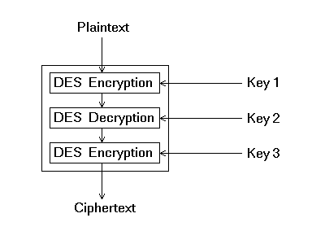
Note that although the input key for DES is 64 bits long, the actual key used by DES is only 56 bits in length. The least significant (right-most) bit in each byte is a parity bit, and should be set so that there are always an odd number of 1s in every byte. These parity bits are ignored, so only the seven most significant bits of each byte are used, resulting in a key length of 56 bits. This means that the effective key strength for Triple DES is actually 168 bits because each of the three keys contains 8 parity bits that are not used during the encryption process.

Advanced Encryption Standard (AES)
The National Institute of Standards and Technology (NIST) established the new Advanced Encryption Standard (AES) specification on May 26, 2002. AES is a new cryptographic algorithm that can be used to protect electronic data. Specifically, AES is an iterative, symmetric-key block cipher that can use keys of 128, 192, and 256 bits, and encrypts and decrypts data in blocks of 128 bits (16 bytes). Unlike public-key ciphers, which use a pair of keys, symmetric-key ciphers use the same key to encrypt and decrypt data. Encrypted data returned by block ciphers have the same number of bits that the input data had. Iterative ciphers use a loop structure that repeatedly performs permutations and substitutions of the input data.

In Depth
The AES algorithm is based on permutations and substitutions. Permutations are rearrangements of data, and substitutions replace one unit of data with another. AES performs permutations and substitutions using several different techniques. AES has a fixed block size of 128 bits and a key size of 128, 192 or 256 bits.

The Steps
AES operates on a 4×4 array of bytes, termed the state. For encryption, each round of AES (except the last round) consists of four stages:
- SubBytes — a non-linear substitution step where each byte is replaced with another according to a lookup table.
- ShiftRows — a transposition step where each row of the state is shifted cyclically a certain number of steps.
- MixColumns — a mixing operation which operates on the columns of the state, combining the four bytes in each column using a linear transformation.
- AddRoundKey — each byte of the state is combined with the round key; each round key is derived from the cipher key using a key schedule.
The final round omits the MixColumns stage.

The SubBytes Step
In the SubBytes step, each byte in the array is updated using an 8-bit S-box. This operation provides the non-linearity in the cipher. The S-box used is derived from the inverse function over a Galois field - GF(28), known to have good non-linearity properties. To avoid attacks based on simple algebraic properties, the S-box is constructed by combining the inverse function with an invertible affine transformation. The S-box is also chosen to avoid any fixed points (and so is a derangement), and also any opposite fixed points.

Figure 3: The SubBytes Step
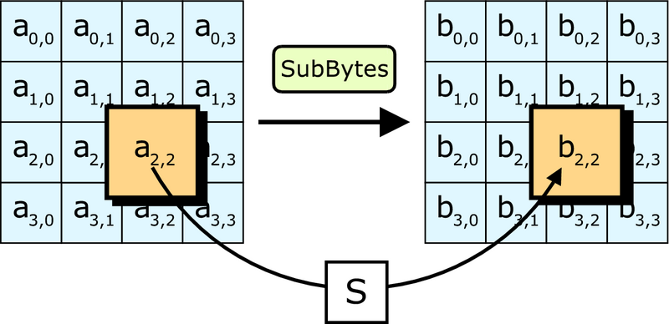

The shiftRows Step
The ShiftRows step operates on the rows of the state; it cyclically shifts the bytes in each row by a certain offset. For AES, the first row is left unchanged. Each byte of the second row is shifted one to the left. Similarly, the third and fourth rows are shifted by offsets of two and three respectively. In this way, each column of the output state of the ShiftRows step is composed of bytes from each column of the input state. (Rijndael variants with a larger block size have slightly different offsets).

Figure 4: The ShiftRows Step

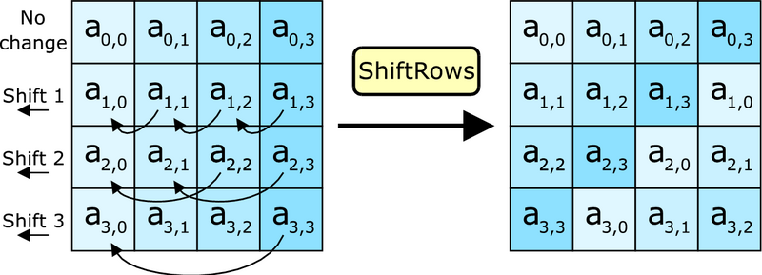

The MixColumns Step
In the MixColumns step, the four bytes of each column of the state are combined using an invertible linear transformation. Together with ShiftRows, MixColumns provides diffusion in the cipher. Each column is treated as a polynomial over GF(28) and is then multiplied modulo x⁴+1 with a fixed polynomial c(x).

Figure 5: The MixColums Step
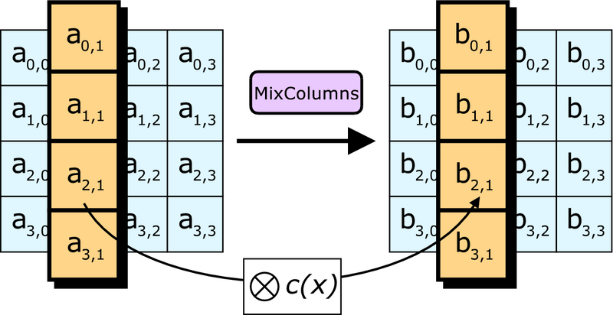

The AddRoundKey Step
In the AddRoundKey step, the subkey is combined with the state. For each round, a subkey is derived from the main key using the key schedule; each subkey is the same size as the state. The subkey is added by combining each byte of the state with the corresponding byte of the subkey using bitwise xor.

Figure 6: The AddRoundKey Step

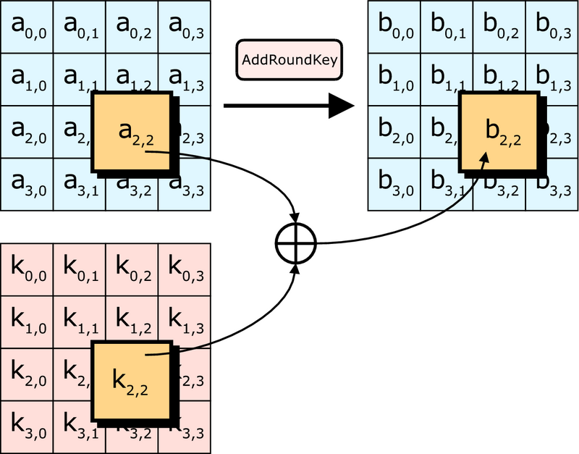

The Future of AES
As of 2004, no successful attacks against AES have been recognized. The National Security Agency (NSA) reviewed that the AES is secure enough for US Government non-classified data. In June 2003, the US Government announced that AES may be used for classified information. This marks the first time that the public has had access to a cipher approved by NSA for TOP SECRET information. It is interesting to note that many public products use 128-bit secret keys by default; it is possible that NSA suspects a fundamental weakness in keys this short, or they may simply prefer a safety margin for top secret documents (which may require security decades into the future).

Protection Mechanisms
Over time, different forms of protection techniques have been developed and researched in an attempt to find more secure methods of securing information stored and accessed via RFID technology. Currently, some of these systems are in use, while others are still being drafted, in order to more effectively achieve their purpose. Some of these schemes are discussed below in further detail.

Juels-Pappu Banknote Protection Scheme
The European Central Bank had wanted to embed RFID tags into the Euro notes in order to be able to track monetary flow, while prohibiting unauthorized access. Similar techniques, as seen in Exhibit 6 of the Appendix, show how similar technology is rumored to be used in the paper money of the United States. For example, avoiding banknote counterfeiting was a major concern in their decision. However, at the same time, they had to be wary of other consequent concerns. When working with such problems, privacy has always become a prevalent issue. In addition, merchants want to protect the privacy of their clients, while reducing the difficulty of processing transactions. Therefore, the Central Bank needed to utilize a system that addressed all these issues adequately.

Preliminary Discussion
As with all current banknotes around the world, each paper bill is marked with a unique serial number. The European Bank believed that they would be able to take advantage of this type of identification in their development process. By requiring physical, optical contact with a specific key, remote hijackings would become far more difficult. As a result, all illegal activity would require having the money in-hand.
The next step in the plan required the encryption to take place onboard each embedded RFID tag. To do so, it was decided that the tag would transmit an encrypted value of the serial number, and not the specific number itself. By using this approach, tracing the tag would be impossible. Secondly, re-encryptions of this identifier would occur over time, by the merchants, in order to defeat any other tracing attempts. In order to process this re-encryption, optical contact would be required, by using the serial number written directly onto the paper money. Therefore, as a result, without having both the encrypted value and the physical number, it would be impossible to access the contents of the RFID tag.

Requirements
In order to effectively utilize this system, specific restrictions were placed on the type of RFID tags that could be used. First, since it would be necessary to store additional data onboard the tag, the embedded memory would require at least 780 bits on an EEPROM (Electrically Erasable Programmable Read-Only Memory). Fortunately, most RFID tags currently on the market have 950 bits of storage.
The other requirement was far more difficult to attain. Each tag would require the use of four instructions: read, write, keyed-read, and keyed-write. Typically, available RFID tags have the capability of the first three instructions, but very few take advantage of the keyed-write function. This obstacle was quickly overcome by the use of specialized tags.

Encryption Process
The process of encrypting the values can be split into several steps, each of which is described later. Through this mathematical analysis, the variables stand for the following values. At the same time, please note that some values are not included because information is unavailable for them, due to confidentiality from the European Central Bank.

Table 16: Variables Used in Juels-Pappu Banknote Protection Scheme
Variable | Function | Storage Location
S | Serial number | Optical
∑ | Serial number | Optical
C | Encrypted value | RFID
R | Random number | RFID

Initial Banknote Creation
When first minting each paper note, the following process will be used.

1. The Central Bank will select a unique serial number S and then compute as in Equation 1 below, through a sign function. It is crossed with a Serial Key and a secondary function.

Equation 1:
∑ = Sign(SK_{B},S||den)

2. Next, an access key, D, will be computed through a hash function as in Equation 2.

Equation 2:
D = h(∑)

3. The next step is to encrypt the value into C with a random number, r, as seen in Equation 3.

Equation 3:
C = Enc(PK_{L}, ∑||S,r)

4. Now that all the values have been calculated, C and r are stored into the RFID memory. C is stored into the λ-cell portion of the tag and r is stored into the δ-cell.
5. Lastly, the two serial numbers, S and ∑, are printed onto the note itself.

Re-Encryption
When paper money changes hands at a merchant, the re-encryption process occurs. This action takes place in order to randomize the secret key to block unauthorized monetary tracking. The process below describes what occurs during this time.

1. The two serial numbers, S and E, are read visually, so that D may be calculated via a hash function as in Equation 4.

Equation 4:
D = h(∑)

2. Next, using D, C and r and calculated in the same way as the initial banknote creation, via Equation 3 above.
3. Then, the calculated C value is verified through the special encryption function in Equation 5.

Equation 5:
C = Enc(PK_{L}, ∑||S,r)

4. A new random number, r, is selected and then keyed-written into the δ-cell portion of the RFID tag.
5. The new encrypted value, C, is calculated using Equation 6 and then stored into the λ-cell.

Equation 6:
C = Enc(PK_{L}, ∑||S,r)

Tracing
When attempting to trace a paper note, the steps below are followed in order.

1. The encrypted value C is freely obtained from the λ-cell portion of the RFID tag.
2. C is decrypted using SK_{L} in order to calculate ∑, through Equation 7 below.

Equation 7:
Dec(SK_{L},C) = ∑||S

3. ∑ is verified to be valid.

Effectiveness
Although the European Central Bank has adopted the Banknote Scheme to help improve the RFID security in their paper money, there have been some drawbacks uncovered over time.

Re-Encryption
In this technique, the re-encryption process is critical to its success. If the re-encryption portion ever fails, the entire scheme offers virtually no protection. It will become quite simple to retrieve data from the individual RFID tags, with no defense mechanism. In addition, since the re-encryption action is triggered by an external device, rapid re-encryption can cause secondary problems. For example, since passive tags are utilized, this process could render the tags useless by draining the internal power.
Invalid re-encryptions can also take place by using unauthorized scanners. If the technique is ever duplicated inaccurately, then false data could be stored on the internal memory.

Public Access Key
The use of a pre-determined access key (the serial number) was selected in order to provide an additional layer of protection by requiring visual contact with the banknote. However, at the same time, it causes more problems relating to the tracing of the tag. While the primary usage of the RFID tag requires both optical and technical communication, a second application allows for data retrieval without the visual aspect. This option was added in order to allow law enforcement agencies to track monetary flow remotely. In order for this function to work, there must be some method of accessing the tag without visual contact. Therefore, it is possible for unauthorized access to the tag via the same protocol.

ElGamal Encryption Scheme
Although the Juels-Pappu Banknote Protection Scheme has proven to be quite effective, it follows an ElGamal-based encryption scheme, rather than the standard use of elliptic curves. This method has become more effective at securing RFID communication. In this case, messages and all transferred information are encrypted with a public key. Then, the data is transferred after being encrypted by Equation 8. Table 17 includes the function of each variable.

Table 17: Variables Used in ElGamal Encryption Scheme
Variable | Function
E^{sym} | Symmetic Encryption
E^{asym} | Asymmetric Encryption
h₁ | Hash Function
h₂ | Hash Function

Equation 8:
E*(k,m) = (E^{asym}(k,r,h₁(r,m)),E^{sym}(h₂(r),m))

In this technique, the asymmetric encryption is the primary purpose and advantage of the ElGamal scheme. Further details regarding this method are difficult to obtain, and are likely confidential and proprietary.

Conclusions
In order to achieve an effective RFID security solution, the usage of an encryption technique coupled with a protection scheme is critical. Through the research described earlier, it has been understood that the AES encryption model would be the leading candidate for accurate and appropriate security. However, the current implementation is far too processing intensive for such a small device. In addition, the memory limitation of 950 bits restricts the effectiveness of the AES algorithm, which requires significantly more storage. Recently, there has been research discussing an alternative method of AES, using less disk space and processing power. This form of “mini-AES” would prove to be perfect for use in RFID tags.
At the same time, additional protection is always needed. By using the Juels-Pappu Banknote Protection Scheme paired with ElGamal Encryption, a secondary layer would prohibit most security risks. Potentially illegal activity could be prevented through the re-encryption techniques and by requiring physical, visual contact with the device.

Through a combination of these technologies, improved security for all RFID tags could be attained, not specifically for banknotes. Similar restrictions could be imposed on consumer devices, such as Digital Signature Transponders (DST) and the ExxonMobil Speedpass mentioned earlier. With the widespread popularity of these small tools, maintaining a more secure network with an increased sense of privacy should be critical. The recommendations set forth in this discussion could easily apply to most current RFID tags and all future revisions.

References
Avoine, Gildas. Privacy Issues in RFID Banknote Protection Schemes. 23 Aug. 2004. 31 Mar. 2005. <http://lasecwww.epfl.ch/~gavoine/download/avoine-cardis-banknote-slides.pdf>.
Avoine, Gildas. Security and Privacy in RFID Systems. 3 Apr. 2005. 21 Apr. 2005. <http://lasecwww.epfl.ch/~gavoine/rfid/>.
Bono, Steve, et al. Analysis of the Texas Instruments DST RFID. 29 Jan. 2005. Johns Hopkins University. 10 Mar. 2005 <http://www.rfidanalysis.org>.
CNN/Money. 17 Feb. 2005 <http://www.cnnmoney.com>.
Feldhofer, Martin. An Authentication Protocol in a Security Layer for RFID Smart Tags. 15 May 2005. Graz Institute of Technology. 16 Mar. 2005. <http://www.iaik.tu-graz.ac.at/aboutus/people/feldhofer/papers/melecon_slides.pdf>.
Technovelgy LLC. Problems with RFID. 2004. 8 Mar. 2005. <http://www.technovelgy.com/ct/Technology-Article.asp?ArtNum=20>.
The Star Online TechCentral. 17 Feb. 2005. <http://star-techcentral.com/tech/story.asp?file=
/2005/1/31/technology/10046004&sec=technology>.
VeriChip. 2004. 17 Feb. 2005. <http://www.4verichip.com>.
Appendix

Exhibit 1: Sample RFID Tag in Relation to a US Dime
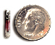

Exhibit 2: Sample RFID Tag in Relation to a Human Finger
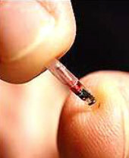

Exhibit 3: Sample RFID Tag Found in Speedpass Device



Exhibit 4: Series of FPGAs Used in Defeating 40-Bit Texas Instruments Security

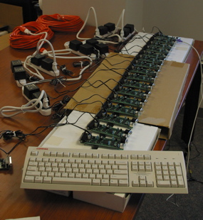

Exhibit 5: Additional Technology Used in Defeating 40-Bit Texas Instruments Security

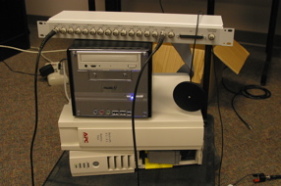

Exhibit 6: Sample US Banknotes with Blown RFID Tags



