Sniper Detection Using Wireless Sensor Networks

Joe Brassard
Wing Siu

EE-194WIR: Wireless Sensor Networks
Tufts University
May 2005
Introduction
The goal of EE-194 Wireless Sensor Networks as a course was to allow the students to learn about wireless sensor networks by researching current technology, performing presentations on that technology, and writing papers. Some groups decided to come up with their own projects, their own simulations. Our group, however, decided that the best way for us to learn about the topic was to study applications utilizing wireless sensor networks and present them to the class at both a “big-picture” high level as well as a system-architecture level.
Our research focused on the general topic of using wireless sensor networks as a counter sniper tool. This means using wireless nodes to identify that a rifle shot has taken place and to track the sound and shockwave created by the shot in order to work backward until the location of the sniper is found. Such a tool is desperately needed for the military, police, etc. We looked at numerous systems, and focused on two: BBN’s “Boomerang”, and Vanderbilt University’s “PinPtr”. From both of these systems our understanding of wireless sensor networks grew. Both systems will be discussed in detail in this report, as will some of the underlying middleware services (such as time synchronization and message routing) that these systems rely upon.
Researching these systems, especially “PinPtr”, gave us not only a technical working knowledge of how wireless sensor networks operate, but also how they can be used at the application level. Studying a topic outside of the pure theoretical arena is paramount to being able to properly utilize the information we have learned in this class; not just from our own presentations and research, but also that of every other group.
Before we begin, some basic terminology should be defined. “Muzzle blast” is the sound created by a rifle barrel after a shot. It expands outward from the barrel in a spherical pattern at the speed of sound. “Shockwave” is the pressure wave that is created by a supersonic bullet. It expands conically along the path of the bullet. Both of these are key factors in how BBN and Vanderbilt decided to track a rifle bullet.

Current Technologies
BBN Bullet Ears, Boomerang I and II
In the mid 1990s, as a response to ongoing sniper attacks in Bosnia, the Defense Advanced Research Projects Agency (DARPA) funded a program to research viable methods for detecting and dealing with snipers. Approximately five systems were developed, one which was from BBN Technologies, a Cambridge, MA based government contractor.
Named “Bullet Ears,” the BBN system is primarily acoustics based and uses shockwave and muzzle blast information to determine a bullet’s trajectory. It is designed to be flexible and adaptable to multiple protection scenarios. To that effect, sensors for the system can consist of four-element tetrahedral microphone arrays, omni-directional microphones, and/or helmet mounted microphones. Sensors can be hardwired into the system or communicate via a RF network. Multiple sensor configurations are necessary because different protection scenarios require different setups: for the purposes of “VIP” protection, sensors can be stationary and hardwired because the protection zone does not move; however, in a warfare situation, the protection zone is likely in constant motion and must communicate wirelessly.
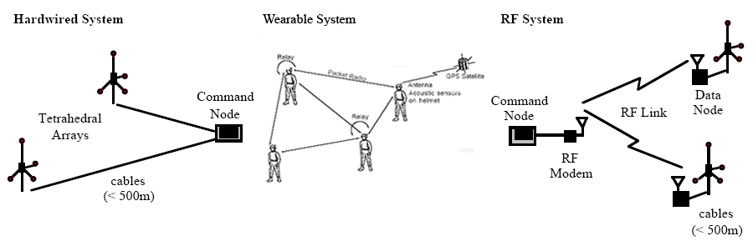
Figure 1: Sensors in the BBN Bullet Ears system can be configured in multiple ways. [2]
Because there are many variables that cannot be controlled (i.e. a sensor cannot obtain shot information or is unable to send, the shooter is using a silenced weapon, etc.), the BBN algorithm is designed to be robust. It can provide limited shooter localization data with information from just one sensor. With the addition of data from more sensors, more precise information is obtained. For example, if muzzle blast information can be obtained, the shooter’s exact location can be pinpointed; if not, the bullet’s trajectory is estimated.
The event of a bullet being fired is capable of generating massive amounts of information. A one second shot snippet contains 500 kilobytes of raw acoustical data. If all the sensors in the network were to send all of the information it received, it could overwhelm the network. Only 1 kilobyte of data from the one second shot snippet is required by the system to process shot information. Thus, sensors were designed to filter out and send only the relevant portion of the data.
It was desired that Bullet Ears be a cost-effective, flexible, and easy-to-use system. The solution was to build Bullet Ears from commercial-off-the-shelf (COTS) products, such as Pentium laptops, generic weatherproof microphones, and 2.4GHz wireless LANs. This lowered both the equipment and system maintenance costs.
Two Bullet Ears “proof-of-principle” systems were eventually developed, a “RF” (wireless) and a “hardwired” system. Sensors in the “RF” system acquire time synchronized data and process data (i.e. anti-alias filtering) on up to 4 20 kHz channels and send the data on a 2.4GHz wireless LAN to a command node. The hardwired system leaves processing details to the command node.
In the spring of 1996, the Bullet Ears POP system was tested with live fire in the Mobile Operations, Urban Terrain facility at Camp Pendleton, California. Several hundred rounds, using bullets of various calibers (22, 30, and 50 caliber rounds), were fired from various locations to test the system’s effectiveness. Most of the testing was performed using two tetrahedral array microphones spaced 40m apart. This was the weakest sensor configuration that the prototype system could handle. Despite this weak configuration, the Bullet Ears system performed well. On day two of testing, 167 shots were fired; Bullet Ears managed to detect 90% of shots. The azimuth was accurate to less than 5 degrees 93% of the time, while elevation estimations were less than 5 degrees off 91% of the time. Overall, the system had a 1.2° RMS azimuth and 3° RMS elevation error.
Bullet Ears is a fixed system. However, as discussed above, a helmet mounted system can be designed so that it can be used for portable applications as well. This wearable system requires additional equipment in order to operate, namely a Global Positioning System (GPS). A GPS is required in order to localize the sensor. The sensor array for the wearable system consists of twelve microphones, mounted flush on a standard issue army helmet. In addition to the flush mounted microphones, the helmet is outfitted with a head mounted display so that the shooter information can be relayed to the soldier. Though a prototype of such a system was built, it was only tested under a non-moving situation. Both multiple- and single-helmet situations were tested. Testing was limited due to poor weather conditions; only 20 shots were fired for the multi-helmet test. In these limited conditions, the multi-helmet system detected 100% of shots and was accurate within 5 degrees azimuth 90% of the time.
Despite the fact that Bullet Ears performed well in the tests at Camp Pendleton, the system was a proof-of-concept model and not ready for actual use. In the words of BBN engineer Scott Ritter, the system was akin to a “science fair project.” Essentially, Bullet Ears remained in this stage until Operation Iraqi Freedom in 2003, when the government asked BBN to deliver a system for use in the war. Two months later, Boomerang was born. Boomerang is a Humvee mounted system that provides both audio and visual feedback in response to a shot fired at the system. It was designed to have a one second response time, accurate to ±15 degrees and 30 meters, have a detection range of up to 150 meters, and work in difficult situations (i.e. traveling at speeds up to 60MPH, withstand dusty environment, etc.).
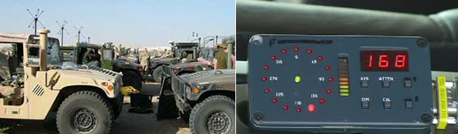
Figure 2: Bullet Ears was the forerunner to Boomerang, which is shown mounted on U.S. military vehicles in Iraq (left). A display inside the vehicle announces the location of the shot (right). [4]
Based on feedback from the field, Boomerang was further improved in 2005. Among other improvements, the new system, named Boomerang II, added shooter elevation level detection and improved noise handling.

PinPtr
A fine example of a sensor network based countersniper system is an experimental prototype called “PinPtr”, developed by a team of researchers at Vanderbilt University [8]. As this system utilizes a number of middleware concepts pertaining to wireless sensor networks, it will be analyzed in this section of the report.
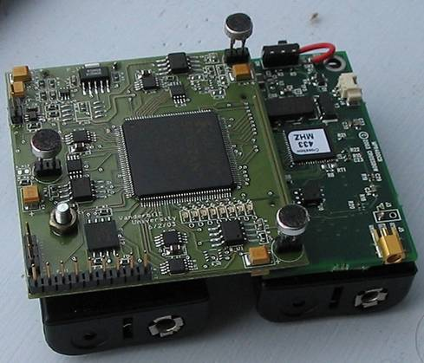
PinPtr is a combination detection system; that is, it utilizes both shockwave detection as well as muzzleblast (audio) detection. To this end, a specialized sensor board was created by the Vanderbilt team with low-sensitivity microphones in addition to pressure sensors for the shockwave. Figure 3 shows the customized sensor board attached to a standard Mica2 wireless mote.
Figure 3: Mica2 mote with custom sensor board.

The PinPtr system is made up of many nodes (as many as needed depending on the deployment area). These nodes record various signals depending on each shot, and send their data back to the base station for calculations. The basic system architecture can be seen in Figure 4.

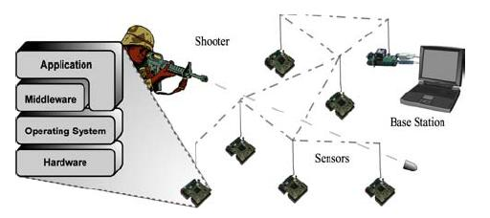
Figure 4: PinPtr system architecture.

The detection algorithm Vanderbilt devised is based on two main assumptions about a bullet. One, the muzzle blast expands spherically from the shooter’s location. Two, the shockwave expands conically along the path of the bullet, as seen in Figure 5.
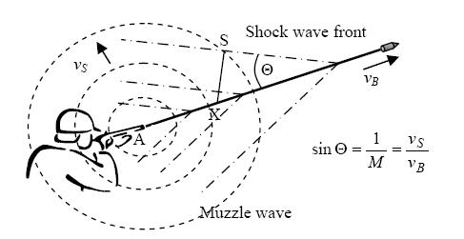

Knowing these two factors, the base station is able to read in the data received from each individual mote and “fuse” the data to calculate the exact position of a shooter. According to the Vanderbilt team, the system has a latency of less than 2 seconds and a 3D localization error of less than 2 meters [8].
Figure 5: Muzzle blast and shockwave path.
Sensor fusion, or the algorithm used to determine where the shooter is located, will not be discussed in detail in this report as it isn’t directly relevant to wireless networks. For more detail on PinPtr’s sensor fusion, see the references page in this report.
The system currently uses the Flooding Time Synchronization Protocol and the Directed Flood Routing Framework. While these middleware services allow excellent performance, they do however have the disadvantage of not allowing any power management. Potential improvements to this will be discussed later on in this report.
Another problem with this system is one of scalability. In order to zone-protect a large area (such as in a city), many nodes are needed. Each new sensor localization requires the nodes to be set up professionally, as an expert will be needed to determine the most effective coverage. This of course affects sensor density (i.e., how much sensor coverage overlap there is within the network). So a deployment team needs to be aware of this in order to prevent gaps in network coverage, or too much overlap providing a flood of redundant data.
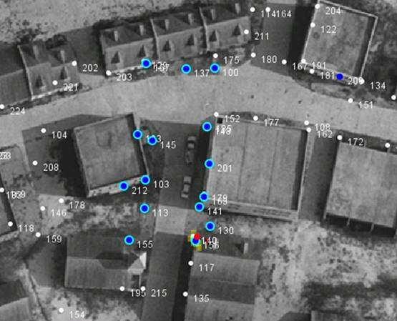
In Figure 6, the base station view can be seen during a simulation test of the PinPtr system. White dots represent motes that did not register a shot event (i.e., either muzzle blast or shockwave). Blue dots represent a mote that did register a shot event. Blue dots with a cyan circle around them represent motes whose data was used by the base station to compute a location. The red dot is the shooter location, and the yellow color is an “uncertainty” area. This uncertainty area is always around the shooter, and is a result of the 2 meter potential error with each calculation.
Figure 7 again shows the PinPtr system in action, this time in a 3D model. This time, the shooter is in the clock tower. The red sphere is the shooter, the light blue spheres are motes that registered the shot event.
Figure 6: 2D screenshot of PinPtr system.
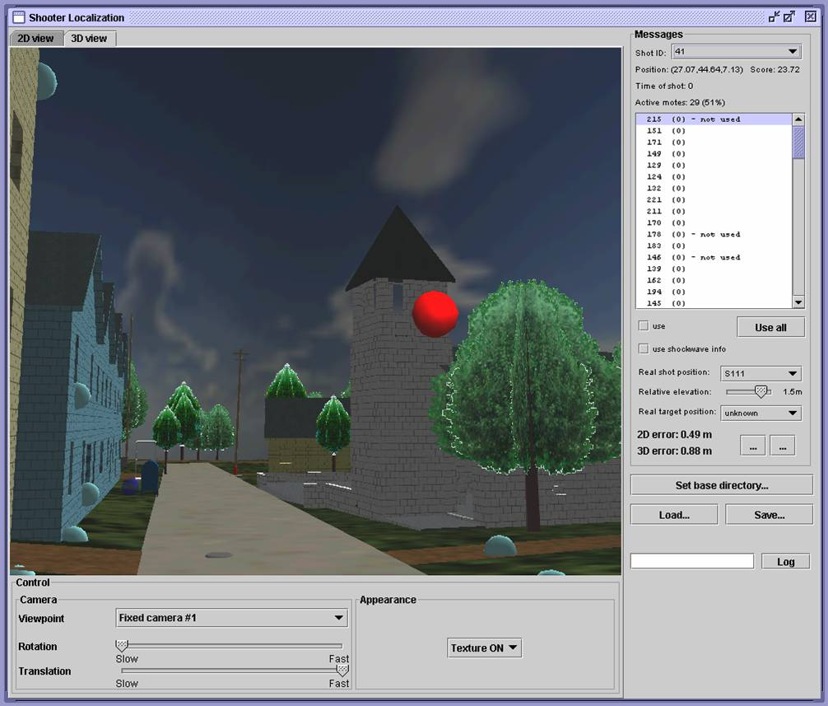
Figure 7: 3D Screenshot of PinPtr system.

This system, while amazingly effective, has the one large downside of not being easy to deploy. For long-term coverage of a single area, this system would be ideal with the addition of a power-management (i.e., “sleep” vs. “awake” nodes) protocol. However, for short term coverage, this system would not be recommended as it takes an awful long time to set up, and requires many nodes. Potential improvements to the system will be discussed in the later sections of this report.
Governing Protocols
Flooding Time Synchronization Protocol
A fundamental problem in tracking a sniper using wireless sensors is that of time. One can place hundreds of sensor nodes in an area, but the data they return cannot be properly interpreted unless the nodes are all running under the same time. The phrase “synchronize watches!” from military and spy movies is very applicable in this situation.
When a base station is trying to interpret muzzle blast (audio) and shockwave (pressure) data from numerous nodes, it needs to know the exact time each reading was received. This allows the base station to determine the path of a shot, since both shockwave and muzzle blast travel at finite speeds. Thus, it can be assumed that if node 1 receives a muzzle blast signal at time T, and node 2 receives a muzzle blast signal at time T+1, an estimate of the path of the expanded muzzle blast sphere can be made. This is true because both the distance between nodes and the speed of sound are both known constants.
The problem, therefore, is how to keep the nodes on a “global” clock. Since clock skew within each node will eventually cause them to all show different times, routine “time synch” messages need to be propagated throughout the network. Such a solution was developed by a team at Vanderbilt University [7], and is called the Flooding Time Synchronization Protocol (FTSP).
The basic concept of FTSP is simple. A “leader” node, chosen by an election, sends out time synch messages routinely. Each node has two time variables: global and local. The goal of FTSP is to set the global time variable of each node to equal the local time variable of the elected leader, via the routine time synch messages.
FTSP works by time stamping each message at both the sender and receiver sides. Now, this does in fact create large overhead, should these messages be sent with frequency. In order to keep this overhead low, linear regression is used to compensate for clock drift in between time synch messages.
Effectively, this is the process: The leader broadcasts its local time (it synchronizes its own global variable to its own local time) and a sequence number. Any and all receivers update their own global variables with the leader’s local time and rebroadcast it. If a node receives a message with a known sequence number, it discards the message as redundant. Each node keeps the last 10 local and global time pairs and performs a linear regression to calculate the precise global time of the leader.
More specifically, each time synch message contains three fields, the timeStamp, the rootID, and the seqNum. The sequence number is set by the leader (or root), and is incremented with each subsequent round of time synchronization. This is to help prevent redundant messages, as each node stores the highest sequence number (highestSeqNum) previously received, and compares the seqNum of each new message with that highest number. If the seqNum is greater than the stored value, the message is valid; otherwise it is discarded as redundant. The timeStamp is the global time as determined by the sender of the message during transmission. The rootID is simply the ID of the root as known by the sender of the message.
In addition to a highestSeqNum field, each node also contains a field called myRootID, containing the ID of the root as known by the node. This is set so that the root (leader) can be elected, if needed. Each node compares the rootID of the incoming message with the myRootID local variable. If rootID is greater than the stored value, the message is discarded, as the message couldn’t have been sent from the root. The root always has the smallest ID of all the nodes.
This is a necessary step for all FTSP messages. If the root were to fail, then (after a set time) all nodes declare themselves to be the root, and begin sending time synch messages. Utilizing the rootID comparison, each node will receive numerous time synch messages. When a node receives a message with a RootID smaller than the stored MyRootID, the node realizes that itself cannot be the root, and stops acting like the root and reverts to a common node.
By combining the sequence number and root ID in each message, there can be an effective filter against redundant messages and redundant roots.
There are, however, issues with FTSP. While it works very well in a wireless sensor network, it leads to disadvantages. For instance, each node must be on and active at all times, as time synch messages are being sent continuously. This does not allow for power management as each node can never be allowed to enter “sleep” mode, or else the potential for a time synch message to be lost is greatly increased. This could cause massive clock skew within the network, and all data received by the base station could no longer be trusted as accurate. This paper will address a potential improvement to this problem in a later section.

Directed Flood Routing Framework
Counter sniper systems generate a massive amount of information in a brief period of time. In order to cope with this information overload, researchers at Vanderbilt University developed the Directed Flood Routing Framework, or DFRF. This framework enables the development of application specific protocols for directed flood routing.
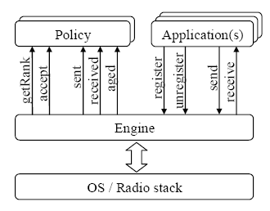
While TCP/IP dominates wired networks as the standard for routing, wireless networks have no such standard. A wireless routing protocol developed for one application and hardware platform might not work well when it is ported to another platform, or used for another application. The Directed Flood Routing Framework (DFRF) was developed to tackle this problem. It acts as a management system for packets on a wireless network, providing customizable “policies” that can be changed depending on the application and/or platform being used. Customizing the protocol’s behavior leads to optimal usage of the network. As with the Flooding Time Synchronization Protocol, the DFRF was initially developed for the Berkeley MICA2 wireless mote system.
Figure 8: A DFRF node -- the engine processes application data based on a defined policy. [5]
Network nodes in the DFRF can be represented by three parts. An engine processes application data using a predefined policy (see figure).
The engine is responsible for all the data sent into and out of the node. Depending on information stored internally and in the application packet itself, the engine determines what to do with a specific packet based on the policy. The possible actions the engine can perform on the packet include: send the packet over the radio stack, hold the packet, “age” the packet, or discard the packet completely.
The Berkeley MICA2 mote has a limited amount of storage for an application packet – approximately 29 bytes. Thus, it is desirable to have as little overhead as possible. Appropriately, the DFRF header consists of only two additional data fields: one for determining the packet type, and another to determine the packet’s “rank.” (figure 9).
Figure 9: A DFRF packet contains the packet’s rank and its type along with its data. [5]
Knowing the packet’s type serves several purposes: first, it helps determine how important the packet is, according to the policy currently in place. Second, it allows packets of the same type to be combined. Because data types in DFRF must have the same size, the engine can examine an incoming data packet’s type and combine packets of the same type if there is already a packet of the same type in the queue and it is not full. This reduces the network traffic – at least one less packet will be sent. Finally, during initialization, the system itself sends packets out to determine what position it is in the chain. These identification packets must be identifiable as such.
In addition to the packet type header, a packet also contains information on its rank. This information is used to determine how far the packet has traveled along its intended path and is rewritten into the packet upon transmission of the packet by the current node. The rank varies by application: it is set by the policy being used. For the gradient converge-cast policy that we will examine later, the rank is the distance the packet is away from the root node; for another converge-cast policy called spanning tree converge-cast, it is the node ID of the parent node, and for a broadcast policy, it is not used (void).
The operation of a DFRF network can best be described using a state machine model. Each packet received by the node is given a priority number from 0 to 255, which is stored internally by the engine and determines what is to be done with the packet depending on policy. Packets with lower priority numbers are usually newer and thus are of more importance than packets with higher priority numbers. The numbers 0 and 255 are special states: 0 indicates that a packet is completely new, and the number 255 indicates that a packet is old and ready to be dropped. Only packets with even numbers are transmitted; packets with odd numbers are held in the system in case they are needed later. The state machine model describes the progress of a single packet through the node. Each priority number is represented as a state in the state machine. The occurrence of an event marks a change in the transition table. Possible events include sending the packet (s), receiving the packet (r), or “aging” the packet (a). “Aging” the packet simply refers to keeping the packet but incrementing the packet’s priority number. As with the packet rank, the state machine’s behavior is dictated by the policy being used. The typical DFRF modes and their state machines, broadcast and gradient converge-cast, will now be presented.
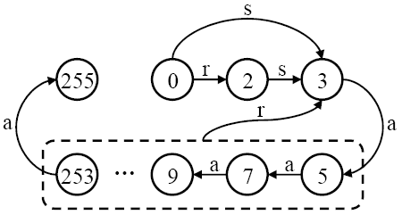
In a broadcast policy, data is sent from a source node to all nodes in the network. Since the packet has no ultimate destination, ranks in this mode are irrelevant and set to “void.” Messages received by the node for the first time are assigned a priority number of 0 to begin with. If it is determined that the packet was received from another node (i.e. it was not generated by this node), the packet is sent and given a priority level of 2 (since it is desired that packets originating from the node be given higher priority). Regardless of whether the packet is assigned a 0 or a 2, the packet is eventually sent by the engine. At this point, it is kept in the engine for approximately 126 aging actions before it is discarded. An alternative to the broadcast policy is the reliable broadcast policy, which works better on linear networks or networks with poor radio collision avoidance. We will not discuss this protocol here because it is not used for the Vanderbilt PinPtr system.
Figure 10: The state machine for the broadcast policy is shown here. [5]
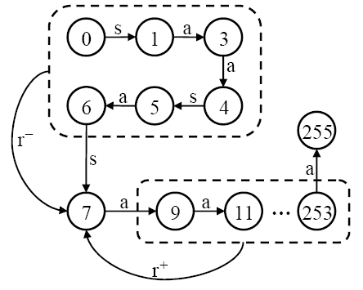
Instead, the PinPtr system uses the gradient converge-cast method, in which all data is eventually sent to one node (most likely the command node in the system). This node is referred to as the root node. Here, rank is important and is used to determine a packet’s distance from the root node. Nodes determine their distance from the root node during initialization: the root node sends out a packet, with rank ID 0. Each node along the chain increments the rank ID by one and sends it down the chain. This number is then used as the rank for outgoing packets. Packets in gradient converge-cast are usually sent up to a total of three times, after which they are simply aged (see figure 12). In the gradient converge-cast system, there are two “received” types: one for packets that are sent from nodes further away from the root node, and one for packets that are sent closer to the root node. These are indicated by r+ and r-, respectively, in the state diagram. Because the packet has likely already been seen by a node closer to the root, packets with r- designations are automatically given higher priority numbers, which means that the packet will not be sent (or if it is, not as much). In the gradient converge-cast system, packets are sent up to three times. One or two aging actions are put in between each of the sends. While the gradient converge-cast policy is fast, it consumes a significant amount of message overhead: the number of transmissions to route a single data packet can grow as the square of the distance between the sender and the root. There is also the potential for data loss if the radio links are not reliable, as is the case for the Mica2 motes.
Figure 11: The state machine for the gradient converge-cast policy is shown here. [5]
Improvements
Here are our ideas to improve the PinPtr system, both from the middleware side as well as the physical side.
Fast Spanning Tree Directed Flood Routing Framework
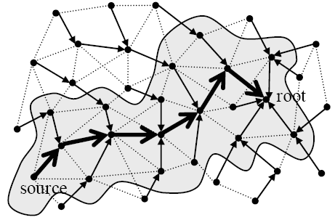
Perhaps a better method for converge-cast message routing is the spanning tree algorithm, nicknamed the Fat Spanning Tree by the Vanderbilt researchers. While the gradient converge-cast policy uses a single path starting from the source to the node, the FAST method uses only a small neighborhood on this path to send data.
Figure 12: A Fat Spanning Tree can also be used for the converge-cast method.
Instead of storing the distance from the root node in the packet, as is done in the gradient converge-cast method, a spanning tree is defined. The lane used is defined as “all nodes one hop away in the spanning tree from the nodes of the path.” [5]. Each node is thus defined in terms of parents, grandparents, and great grand parents. A packet’s rank in this implementation is the grandparent’s node ID. Based on this information, the processing node can: 1) send the packet (r+ condition) if the rank ID is the rank of the receiver or its parent (since the processing node is closer), 2) ignore the packet if the rank ID is the same as the node’s grandfather (since the both sender and receiver are at the same distance from the root), 3) keep the packet (r- condition) if the rank ID is the node ID of the great grandparent or parent of the receiver (since the original sender was already closer to the root), or 4) ignore the message because none of the conditions 1 – 3 apply (since the node is not on the path or too far away).
The details on how to implement a spanning tree to accomplish this are complicated and will not be discussed here. However, it can be shown that the spanning tree converge-cast method does indeed save on network congestion. The graphs below show network usage in the gradient converge-cast method vs. the spanning tree method. It can be clearly seen that the spanning tree method is more efficient. We thus propose using the spanning tree converge-cast method in future implementations.
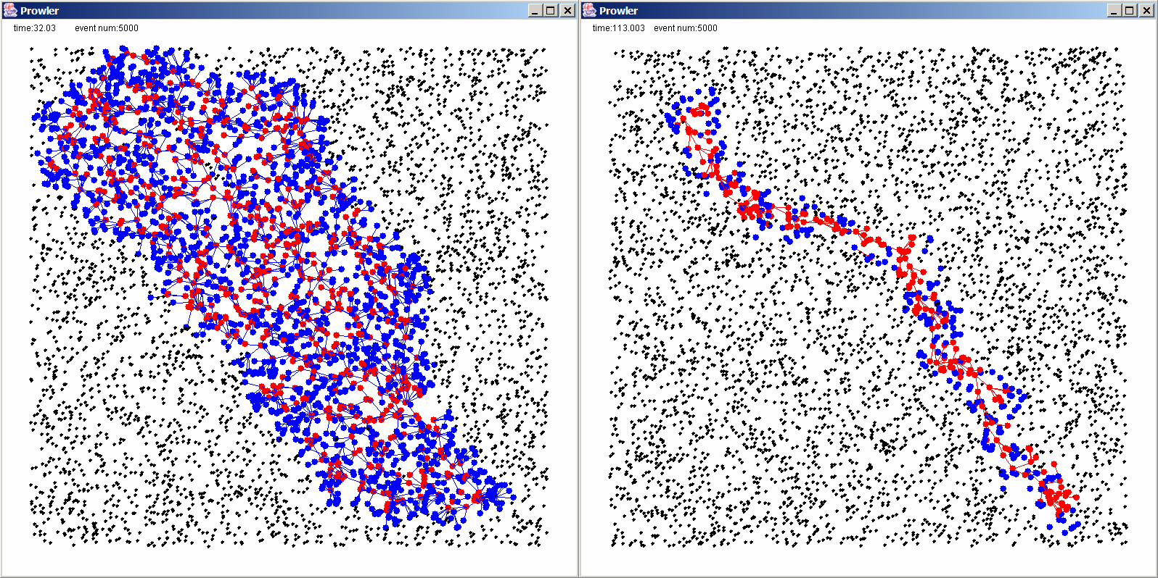
Figure 13: A comparison of the gradient converge-cast method (left) vs. the spanning tree converge-cast method (right) shows considerable network usage improvement. [5]

Routing Integrated Time Synchronization
One of the biggest faults to PinPtr is that using FTSP creates a lot of unnecessary overhead (in many extra time synch messages). It also eliminates the possibility of power management. In order to improve performance, Routing Integrated Time Synchronization, or RITS, should be implemented.
In simplest terms, RITS is an implicit time synchronization protocol. “Implicit” means that the time synchronization is done as part of the regular message routing, not as a separate protocol. This means the motes will only synchronize their global time variables when they transmit or receive data (i.e., after a shot event has occurred.)
The issue at hand is that when a sensor registers a shot event and stamps it using its local clock, the target node (in most cases, the base station) needs to know the time of the event in its own local time. This can be solved by RITS, as seen in Figure 14.
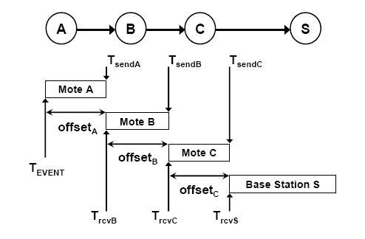
Figure 14: RITS protocol.
Mote A registers an event at time Tevent. A wants to send the data from this event to Mote S, and on the way it needs to be retransmitted by Motes B and C. The transmission time between each mote is seen as offsetA, offsetB, and offsetC, respectively. The time each mote receives the signal is seen as TrcvB, TrcvC, and TrcvS.
The data packet now contains an age field, which contains the time elapsed since the event occurred. This is a very small field, adding little to the overhead of the message. Since the message is time stamped on both the sender and receiver sides, the age field is constantly updated with the total elapsed time since the event. By the time it reaches Mote S, it contains the sum of the offsets. So all Mote S needs to do to determine the exact time of the event is subtract age from TrcvS.
This system allows for power management, as the nodes do not need to be awake constantly in order to wait for potential FTSP messages. Now, each node can lower its power use significantly by entering a “light sleep” mode. Normal operation is roughly 30mA, while “light sleep” is only 5ma. During light sleep, the DSP is idle, while the analog sensor channel is sampled. If a shot occurs, an analog comparator wakes up the node and turns on DSP. Now, this increases the latency of the system, but the first shot is still able to be seen. So, nodes can be alternated into light sleep in order to increase the lifespan of the system.
Conclusion
It is hoped that this report demonstrates our new found knowledge of wireless sensor networks through our research into various existing systems. While we did not simulate or build our own network, we feel that we have garnered a fair understanding of the underlying principles of wireless sensor networks regardless.
It should be noted that we also gained important insight through the presentations of other groups, and used the concepts and problems discovered by those groups toward our own research. In this two-pronged approach, we were able to successfully complete the requirements of the course, as well as gain a decent familiarity with wireless sensor networks.

References
[1] Maroti, Miklos, et. al. “Shooter Localization in Urban Terrain.” Computer August 2004: 60 – 61.
[2] Duckworth, G.L., et. al. “Fixed and wearable acoustic counter sniper systems for law enforcement.” BBN Technologies White Papers. Online (http://www.bbn.com/docs/whitepapers/sniper_spie98.pdf). 27 March 2005.
[3] “U.S. Army Joint Counter Sniper Program.” SpecialOperations.com. Online (http://www.specialoperations.com/Specialties/Sniping/Counter_Sniper.htm). 27 March 2005.
[4] “Boomerang.” BBN Technologies. Online (http://www.bbn.com/For_Government_Customers/Sound_and_Vibration/?name=Boomerang_Sniper_Detection.html&search=boomerang). 27 March 2005.
[5] Maroti, Miklos. “The Directed Flood Routing Framework.” Vanderbilt University. Online (http://www.isis.vanderbilt.edu/Projects/nest/documentation/Vanderbilt_NEST_Routing.pdf). 27 March 2005.
[6] Mazurek, Jeffery A., et. al. “Boomerang mobile counter shooter detection system.” BBN Technologies White Papers. Online (http://www.bbn.com/docs/whitepapers/Boomerang_2005_Approved.pdf). 9 April 2005.
[7] Marioti, Miklos, et. al. “The Flooding Time Synchronization protocol.” Vanderbilt University. Online (http://www.isis.vanderbilt.edu/Projects/nest/documentation/Vanderbilt_NEST_TimeSynch.pdf) 12 April 2005.
[8] Simon, G, et. al. “The Sensor Network Based Countersniper System.” Vanderbilit University.
[9] Ledeczi, Akos. “Sensor Network-Based Countersniper System.” SenSys 2004 Presentation. Online (http://www.isis.vanderbilt.edu/Projects/nest/documentation/Vanderbilt_NEST_Sensys.ppt) 12 April 2005.
[10] Ledeczi, Akos. “Pattern-Oriented Composition and Synthesis of Middleware Services for NEST.” July 2004 Presentation. Online (http://www.isis.vanderbilt.edu/Projects/nest/documentation/Vanderbilt_NEST_Charleston.ppt). 12 April 2005.
[11] Ledeczi, Akos. “Shooter Localization in Urban Terrain.” December 2003. Online (http://www.isis.vanderbilt.edu/Projects/nest/documentation/Vanderbilt_NEST_ShooterLoc.ppt). 12 April 2005.

